# Super Kit Manual

# Description

Super kit is a kit that includes a variety of MCU development boards, including Raspberry Pi Pico, Arduino UNO, Arduino Mega2560, ESP32-WROVER, ESP8266, which can be used to make small smart devices, IoT prototypes, smart home and other applications. It supports C language programming, C++, MicroPython and other language programming, which is great for learning the use and programming of sensors.

**Note:**

The codes and other information involved in the experiments in this book will be stored in the TF card together with the package, and the corresponding example code can also be obtained from the GitHub link. The URL link is: **https://github.com/geeekpi/superkit**

And will be updated from time to time.

## Features

* Easy to use
* Contains a lot of sensors
* Variable MCU Dev boards
* Multiple classic tutorials

## Getting Start

Environmental requirements:

### For Windows

1. PC or laptop

2. Installed Arduino IDE or Thonny IDE

* Arduino IDE Download link: [**https://arduino.cc/**](https://arduino.cc/)

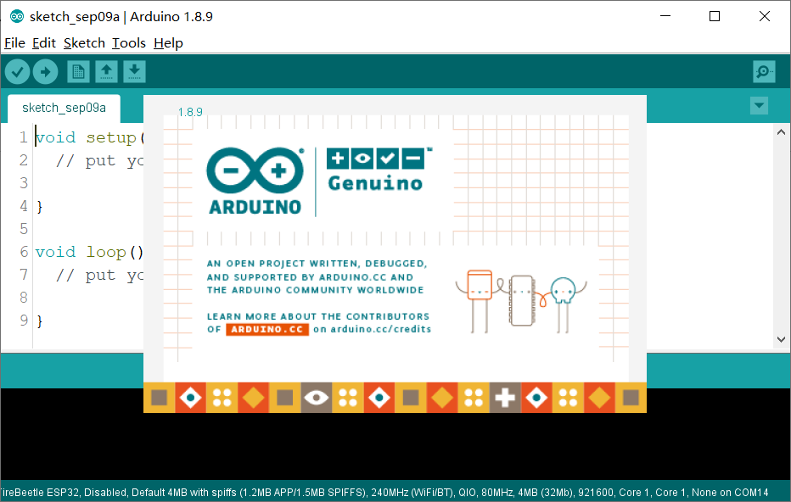

* Thonny IDE Download link: [**https://thonny.org/**](https://thonny.org/)

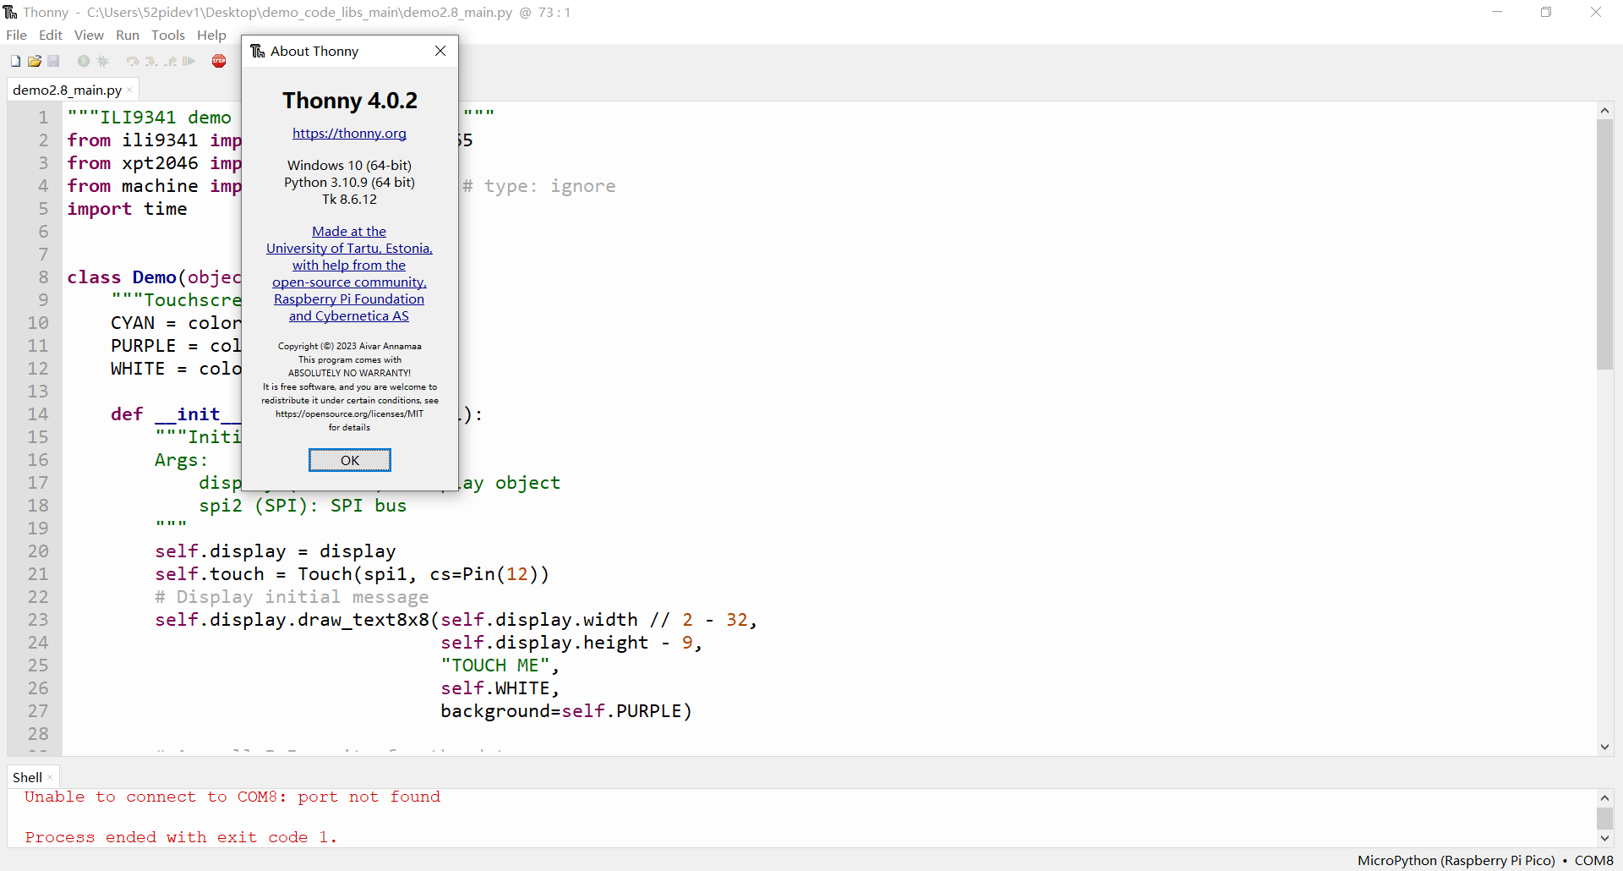

### For Linux or Raspberry Pi

1. PC or laptop

2. Installed Arduino IDE or Thonny IDE

* Arduino IDE Download link: [**https://arduino.cc/**](https://arduino.cc/)



* Thonny IDE Download link: [**https://thonny.org/**](https://thonny.org/)

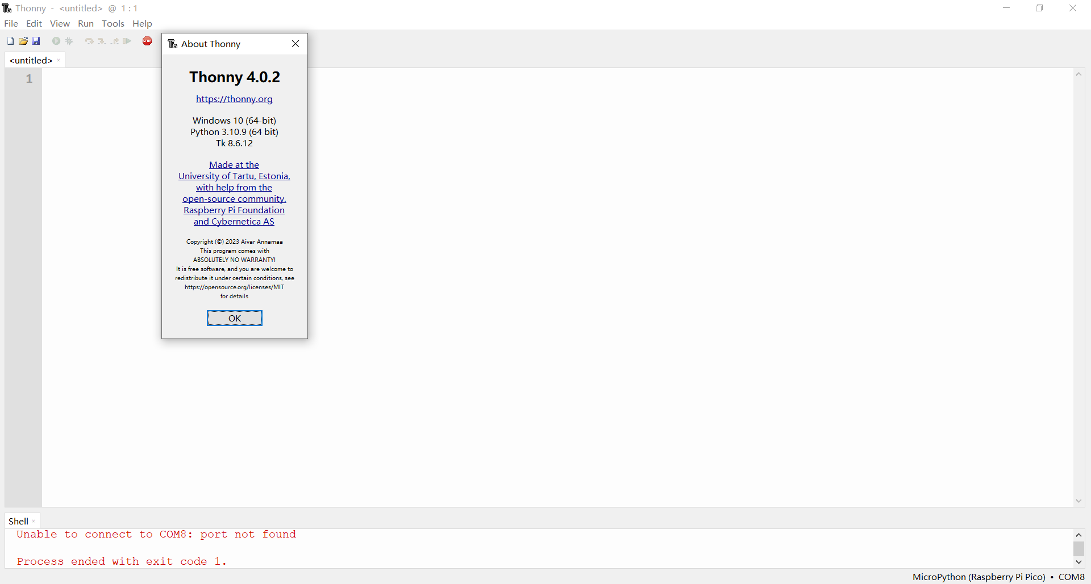

or

Install **arduino-cli** command line tool : <https://arduino.github.io/arduino-cli/0.21/>

**Arduino CLI** is an all-in-one solution that provides Boards/Library Managers, sketch builder, board detection, uploader, and many other tools needed to use any Arduino compatible board and platform from command line or machine interfaces.

In addition to being a standalone tool, Arduino CLI is the heart of all official Arduino development software (Arduino IDE, Arduino Web Editor). Parts of this documentation apply to those tools as well.

Download link: <https://github.com/arduino/arduino-cli/releases/tag/0.26.0>

Please download the tools according to your system, for example, if you are using macOS, select macOS_64bit version. If you are using Raspberry Pi OS 64bit, you can select Arduino-cli_0.26.0_Linux_ARM64.tar.gz, download to your Raspberry Pi and unzip it. copy “**arduino-cli**” file to **/usr/bin/** folder and reboot your Raspberry Pi, and it will be ok.

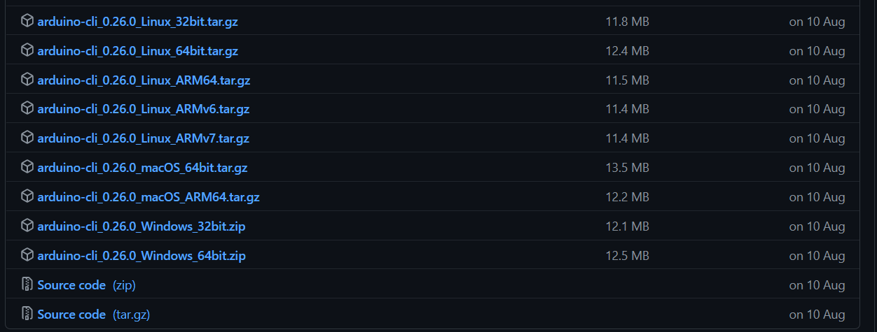

Despite the lack of feature parity at the moment, Arduino CLI provides many of the features you can find in the Arduino IDE. Let's see some examples.

#### Before you start

arduino-cli is a container of commands and each command has its own dedicated help text that can be shown with the help command like this:

$ arduino-cli help core

Arduino Core operations.

Usage:

arduino-cli core [command]

Examples:

./arduino-cli core update-index

Available Commands:

download Downloads one or more cores and corresponding tool dependencies.

install Installs one or more cores and corresponding tool dependencies.

list Shows the list of installed platforms.

search Search for a core in Boards Manager.

uninstall Uninstalls one or more cores and corresponding tool dependencies if no more used.

update-index Updates the index of cores.

upgrade Upgrades one or all installed platforms to the latest version.

Flags:

-h, --help help for core

Global Flags:

--additional-urls strings Additional URLs for Boards Manager.

--config-file string The custom config file (if not specified the default will be used).

--format string The output format, can be [text|json]. (default "text")

--log-file string Path to the file where logs will be written.

--log-format string The output format for the logs, can be [text|json].

--log-level string Messages with this level and above will be logged.

-v, --verbose Print the logs on the standard output.

Use "arduino-cli core [command] --help" for more information about a command.

#### Create a configuration file

Arduino CLI doesn't strictly require a configuration file to work because the command line interface provides any possible functionality. However, having one can spare you a lot of typing when issuing a command, so let's go ahead and create it with:

$ **arduino-cli config init**

Config file written: /home/pi/.arduino15/arduino-cli.yaml

For ESP32 or ESP8266 board, you need to adding following parameters into the config file under /home/pi/.arduino15/arduino-cli.yaml

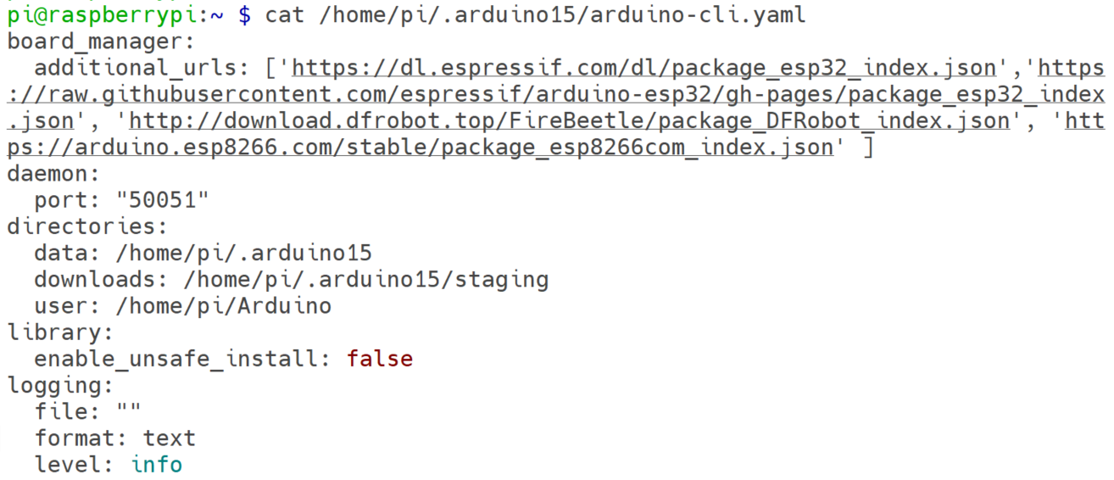

adding following urls to board_manager:

additional_urls: **[**

**'https://dl.espressif.com/dl/package_esp32_index.json',**

**'https://raw.githubusercontent.com/espressif/arduino-esp32/gh-pages/package_esp32_index.json', 'http://download.dfrobot.top/FireBeetle/package_DFRobot_index.json', 'https://arduino.esp8266.com/stable/package_esp8266com_index.json'**

**]**

save it.

#### Update index for core

Run following command in a terminal:

**arduino-cli core update-index**

after that

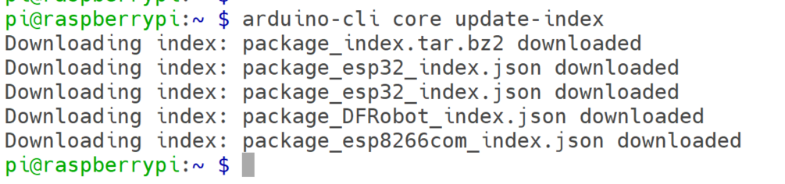

#### Upgrade core

Run:

**arduino-cli core upgrade**

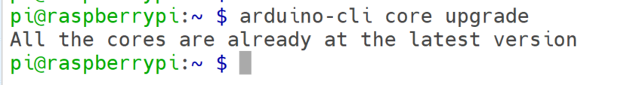

#### List board

Run:

**arduino-cli board list**

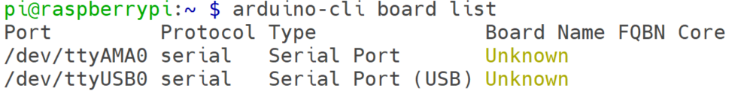

**arduino-cli board listall arduino:avr:uno**

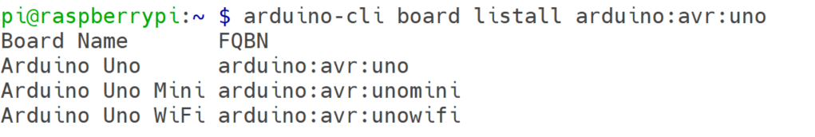

**arduino-cli board details –b esp32:esp32:esp32**

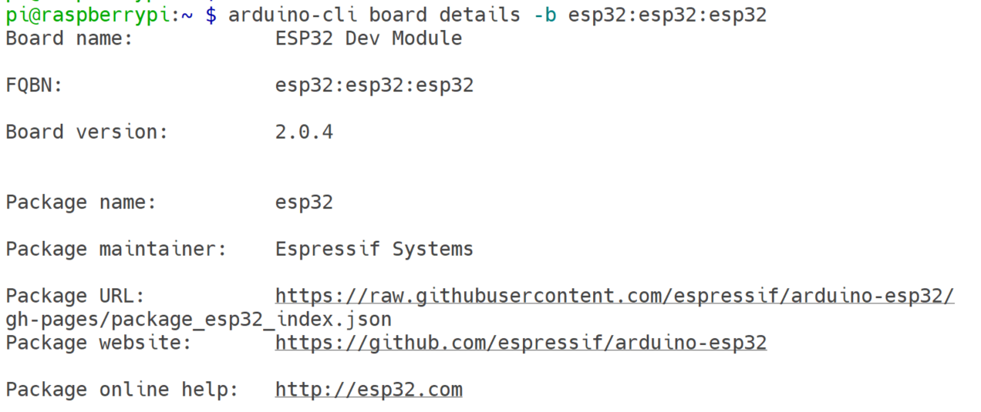

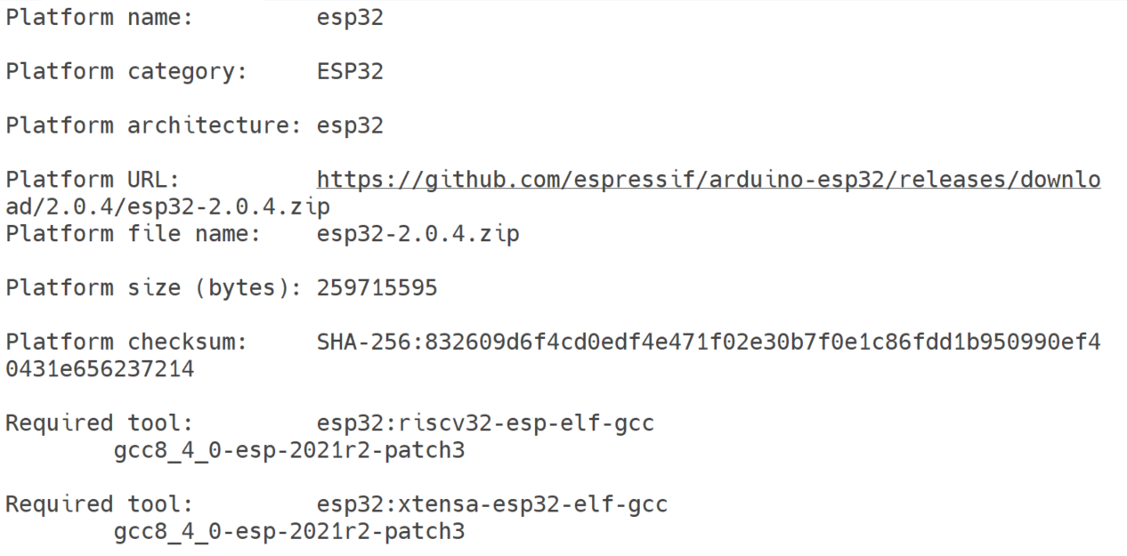

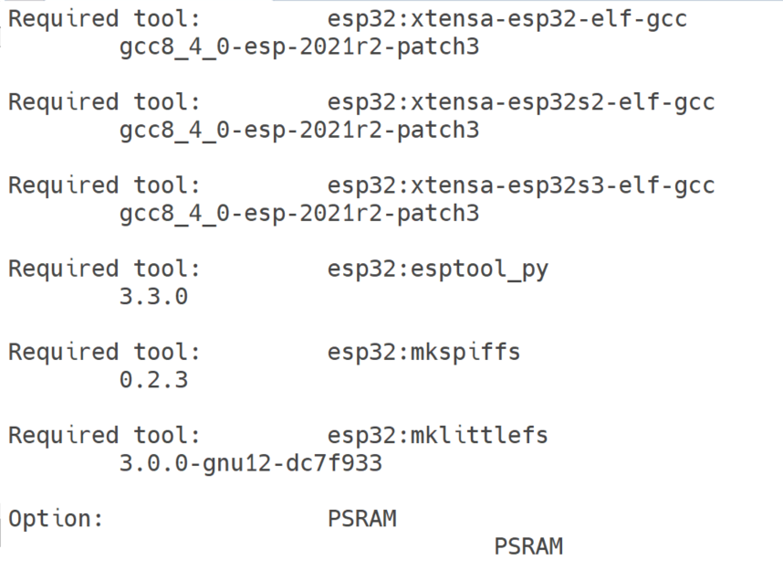

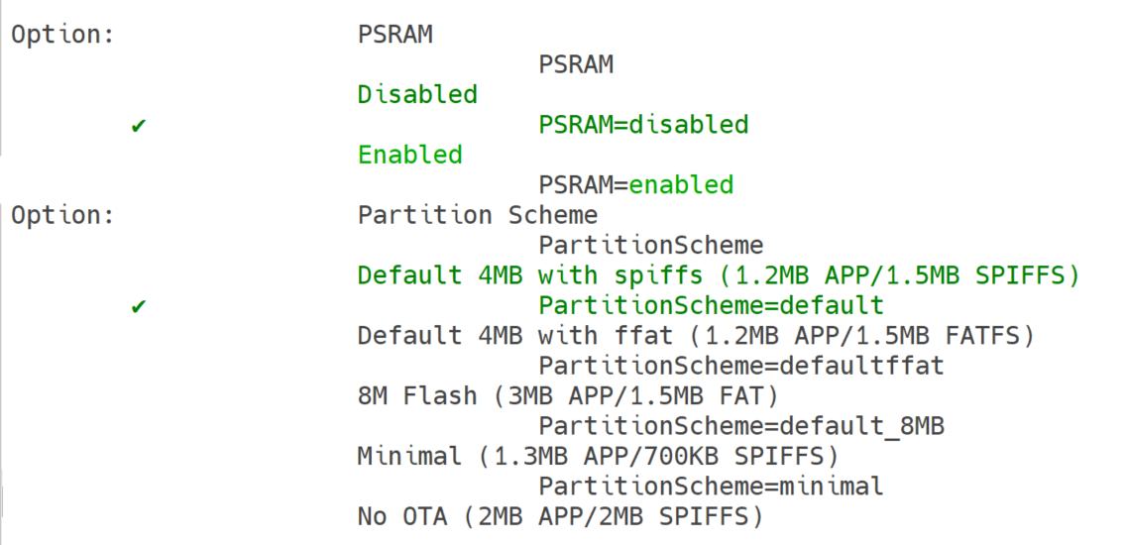

and options details.

#### Install the core for your board

Run:

**arduino-cli core install esp32:esp32**

**arduino-cli core install esp8266:esp8266**

**arduino-cli core install arduino:avr**

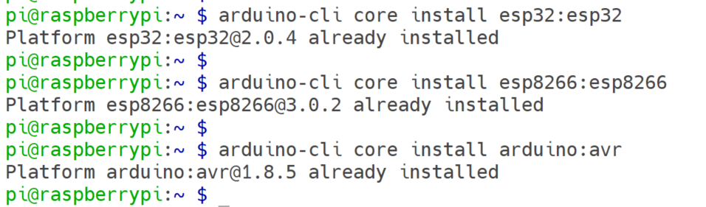

#### Create a new sketch

Run:

**arduino-cli sketch new MyFirstSketch**



Here, you could choose to create a new sketch or just download demo codes from GitHub repository. we have already prepared plenty of demo codes for you as reference documents.

* Demo Code Download URL: [**https://github.com/geeekpi/superkit.git**](https://github.com/geeekpi/superkit.git)

Open a terminal and typing:

**cd**

**git clone** [**https://github.com/geeekpi/superkit.git**](https://github.com/geeekpi/superkit.git)

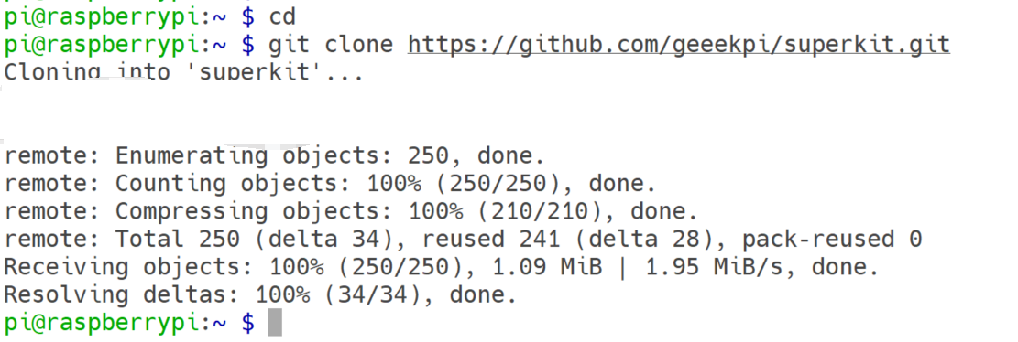

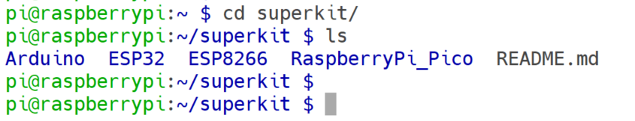

**NOTE: We recommend that you compile and upload demo code to Arduino by using arduino-cli tool，or you can download Arduino IDE to copy and paste demo code into it. If you are using MicroPython language, please use thonny IDE or MU IDE to upload demo code.**

**We have provided multiple demo codes on GitHub web site and it will store in the TF card inside the package.**

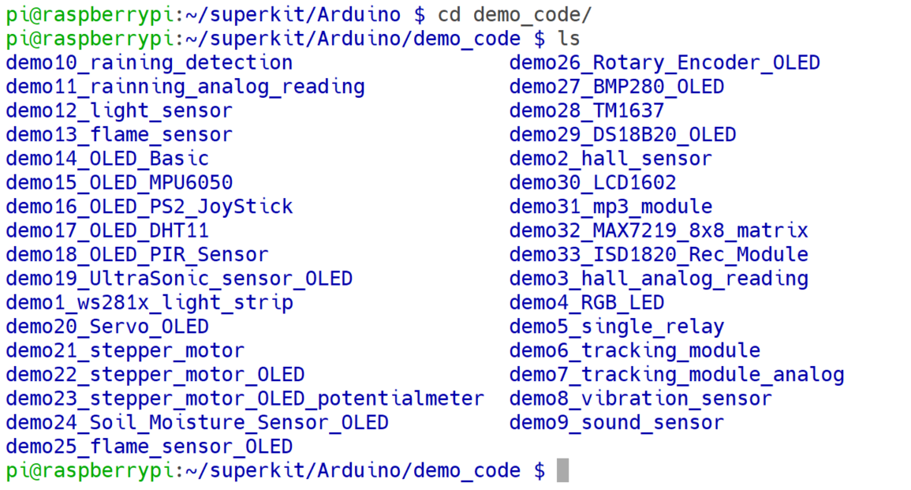

Once you select one demo, please enter into the folder and compile it and upload to your MCU dev board. and connect the sensors according to the pinout diagram inside the folder.

Some of them need to install libraries, please follow the readme.md file to install library and then compile the demo code and upload sketch to Arduino board.

For example:

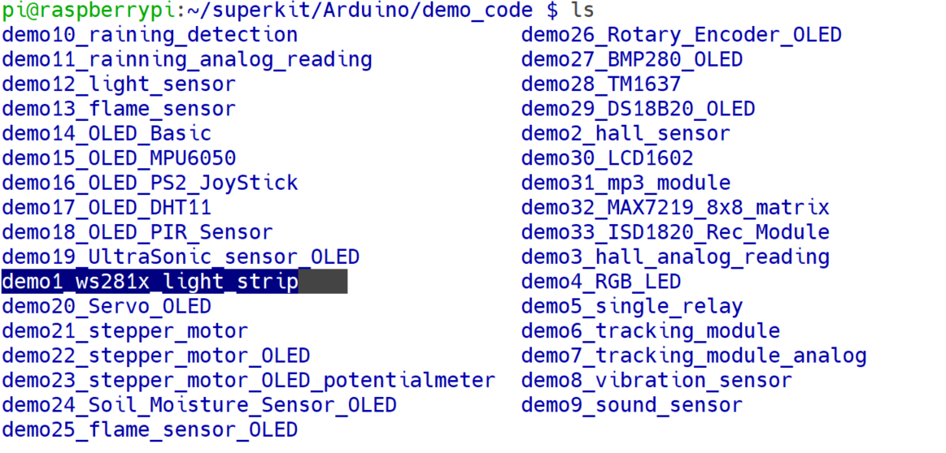

Enter into the folder and read README.md file first.

**cd demo1_ws281x_light_strip/**

**more README.md**

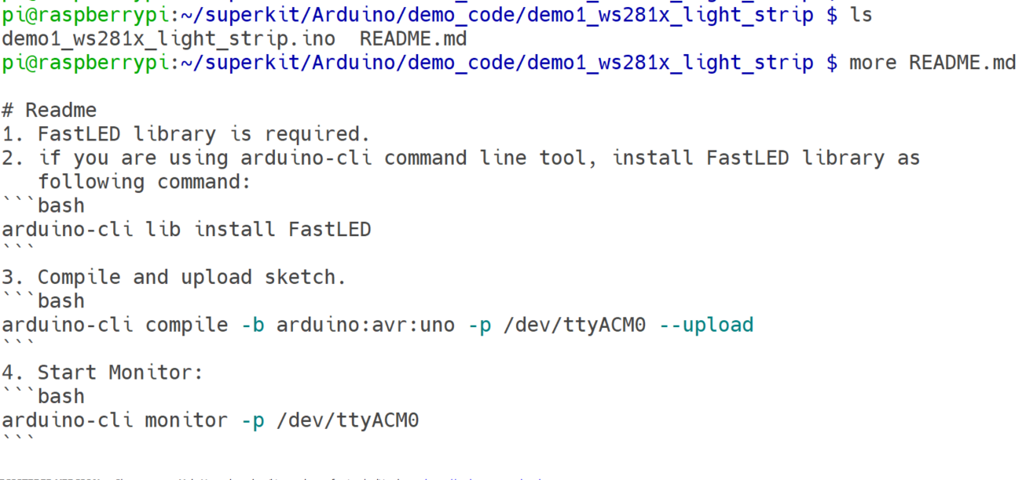

follow the instructions to install libraries.

#### Install libraries.

Run:

**arduino-cli lib search FastLED**

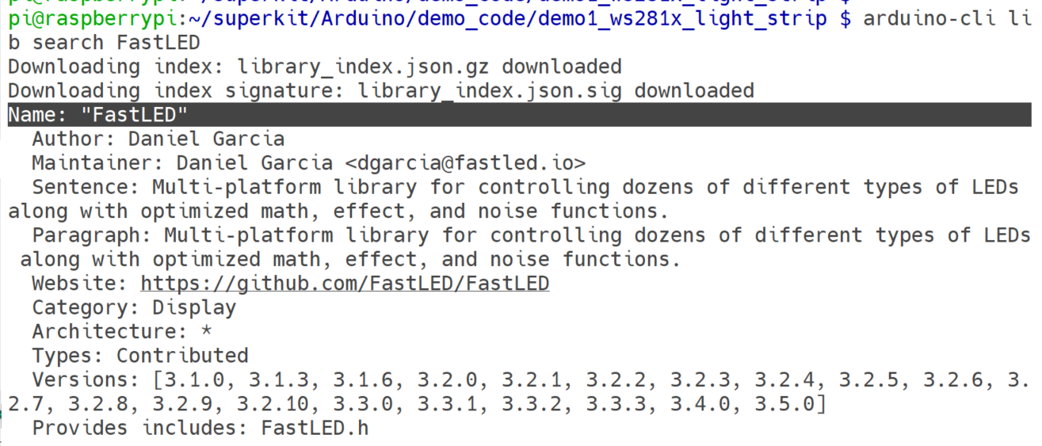

**arduino-cli lib install FastLED**

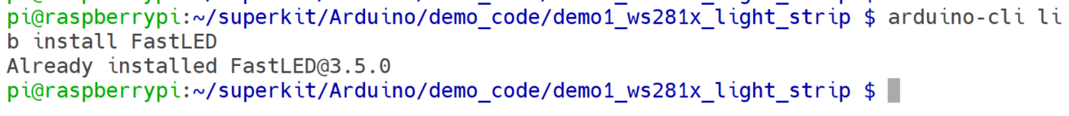

you can modify the sketch file as you wish:

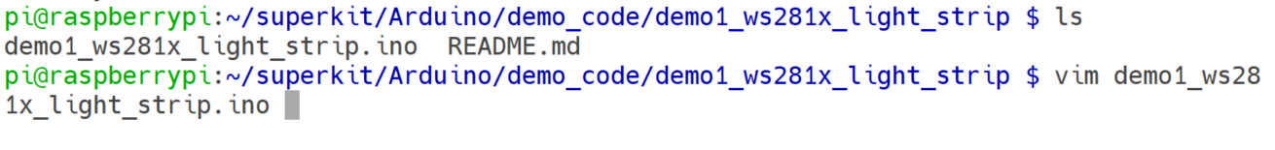

here, let us check out the LED_PIN = 7, means the signal output pin is 7, connect this pin to Arduino Uno board on digital area on pin 7.

save it and then compile it and upload sketch as following steps.

#### Compile and upload sketch

Run:

**arduino-cli compile –b arduino:avr:uno –p /dev/ttyACM0 --upload**

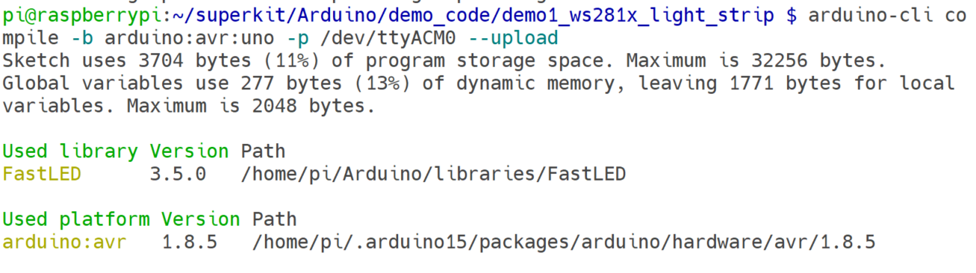

No Error means successful upload the sketch.

you will see the LED strip is lighting up like a rainbow.

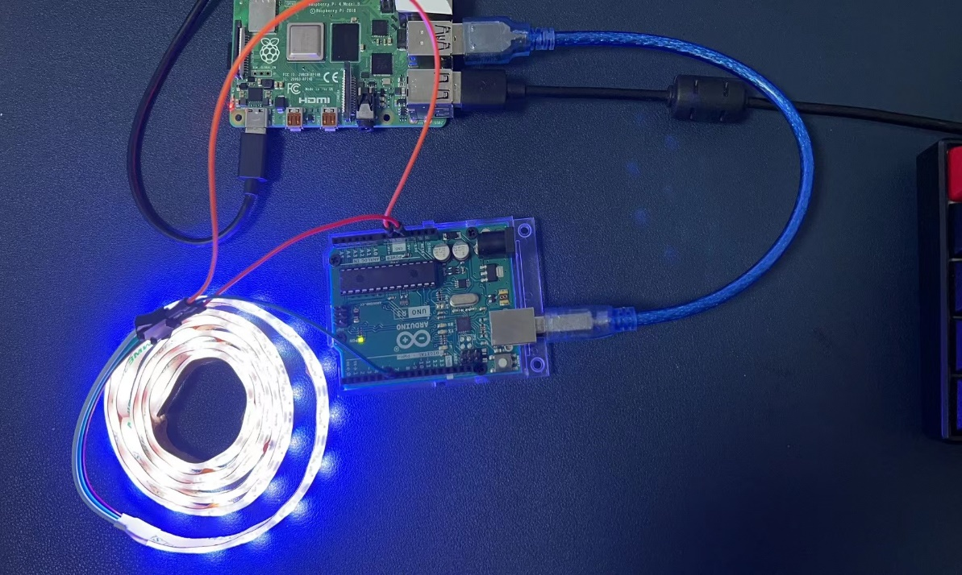

If you want to monitor the value from the serial port, you can modify the code and

Save it and compile it, upload sketch to arduino board and then open a monitor.

**arduino-cli compile –b arduino:avr:uno –p /dev/ttyACM0 --upload && arduino-cli monitor –p /dev/ttyACM0**

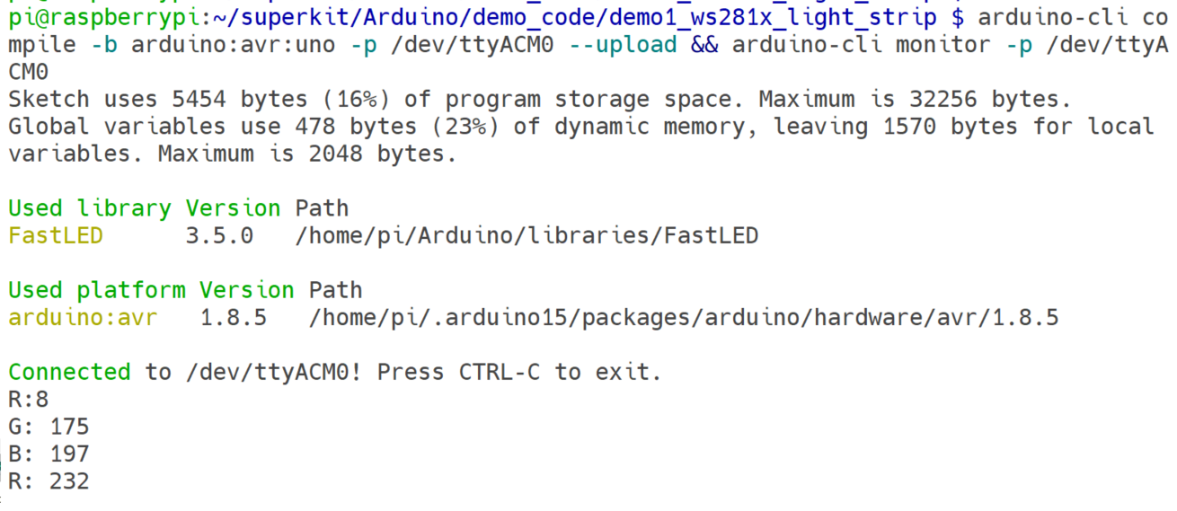

**Others can refer to this operation method to operate.**

##### For ESP32 WROVER

You can also use arduino-cli or rshell to upload demo code to ESP32 WROVER.

* arduino-cli Method:

Just create a new sketch and then modify the *.ino like arduino way.

for example:

Run:

**arduino-cli sketch new blinkLED**

**cd blinkLED**

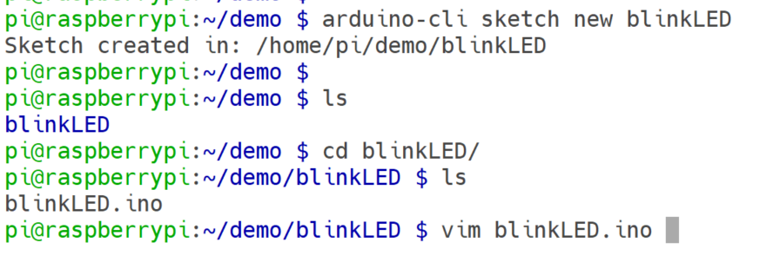

**vim blinkLED.ino**

finish the sketch with following code.

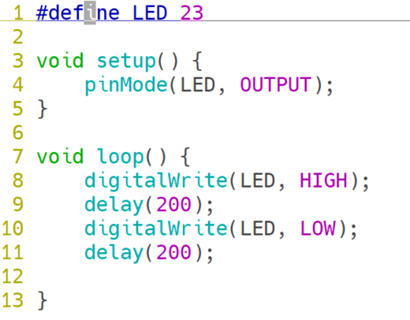

save it and compile & upload sketch.

**arduino-cli compile –b esp32:esp32:esp32 –p /dev/ttyUSB0 --upload**

Connect a LED to 23 an GND, you will see the LED is blinking.

#### If you are using MicroPython

If you are using MicroPython environment for programming on ESP32 and Raspberry Pi Pico, please refer to the operation method below.

* First of all, Download the firmware of ESP32 and Raspberry Pi Pico.

**ESP32:**

<https://micropython.org/resources/firmware/esp32-20220618-v1.19.1.bin>

**Raspberry Pi Pico:**

<https://micropython.org/resources/firmware/rp2-pico-20220618-v1.19.1.uf2>

you can use following command to download the firmware to your Raspberry Pi:

**wget** [**https://micropython.org/resources/firmware/esp32-20220618-v1.19.1.bin**](https://micropython.org/resources/firmware/esp32-20220618-v1.19.1.bin)

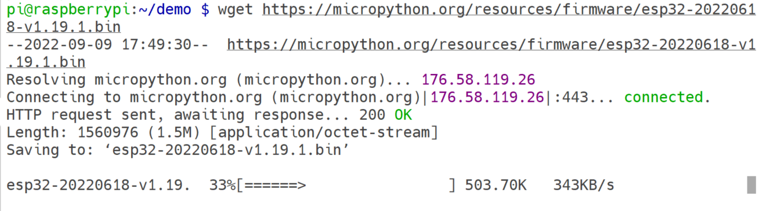

* Connect ESP32 to Raspberry Pi via USB port.

Program your board using the esptool.py program, found here:

[**https://github.com/espressif/esptool**](https://github.com/espressif/esptool)

or just using apt tool to install esptool package:

**sudo apt update**

**sudo apt –y install esptool**

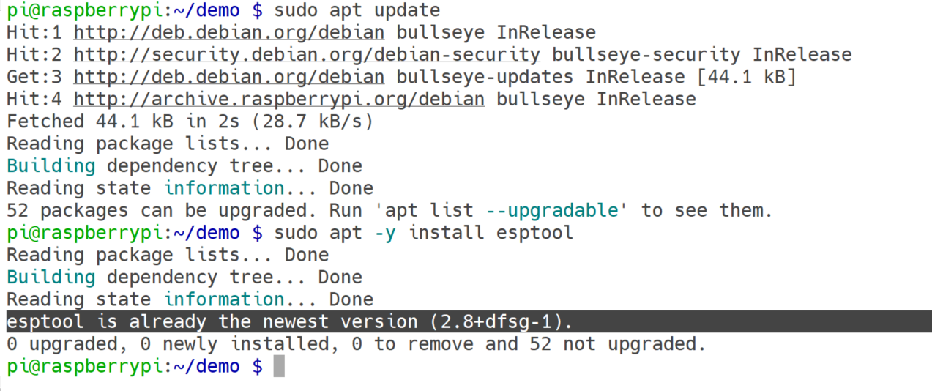

If you are putting MicroPython on your board for the first time, then you should first erase the entire flash using:

**esptool.py --chip esp32 --port /dev/ttyUSB0 erase_flash**

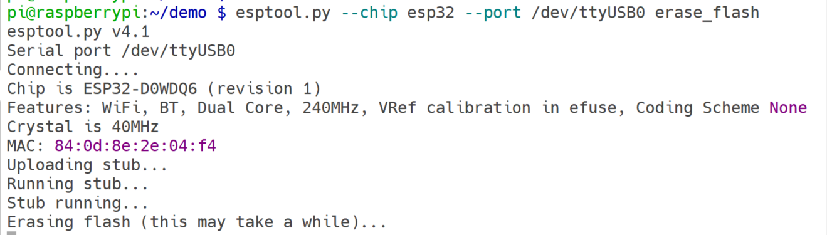

From then on program the firmware starting at address 0x1000:

**esptool.py --chip esp32 --port /dev/ttyUSB0 --baud 460800 write_flash -z 0x1000 esp32-20220618-v1.19.1.bin**

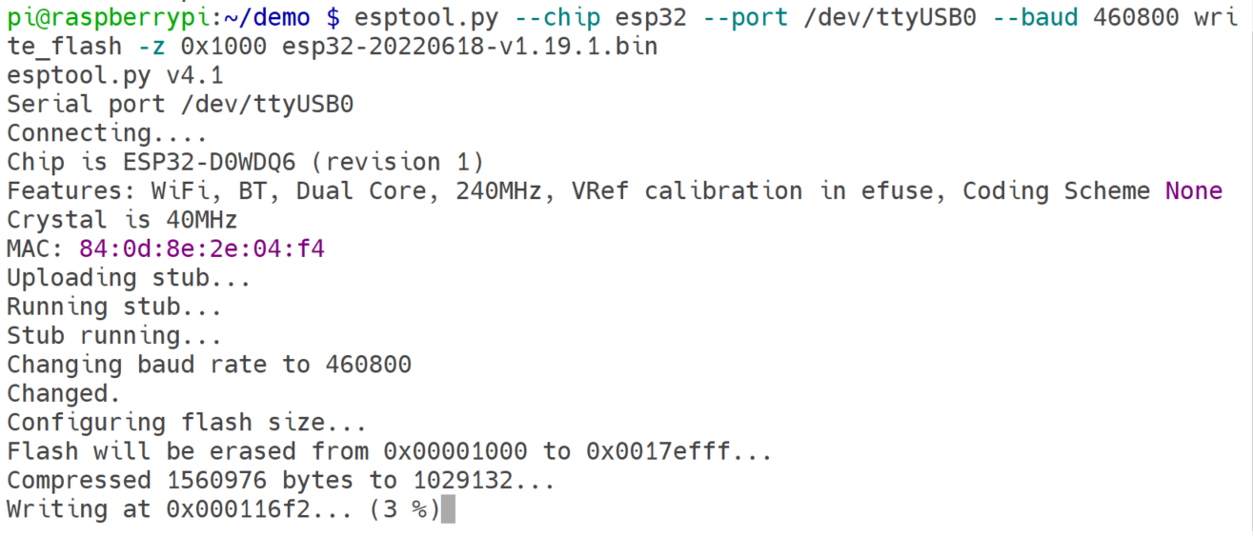

#### Install rshell

**pip3 install rshell**

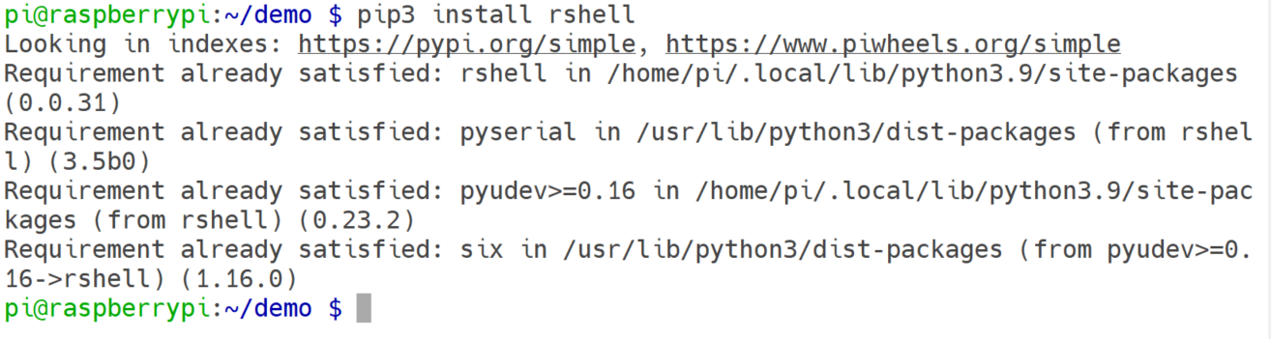

#### Create demo code and upload to ESP32 via rshell tool

**vim blink.py**

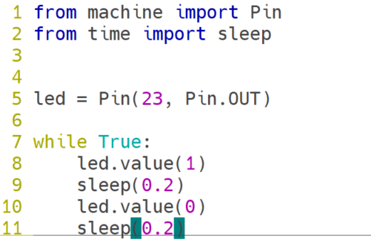

UPLOAD**：**

**rshell -p /dev/ttyUSB0 -b 115200 --buffer-size=4096**

**cp blink.py /pyboard/main.py**

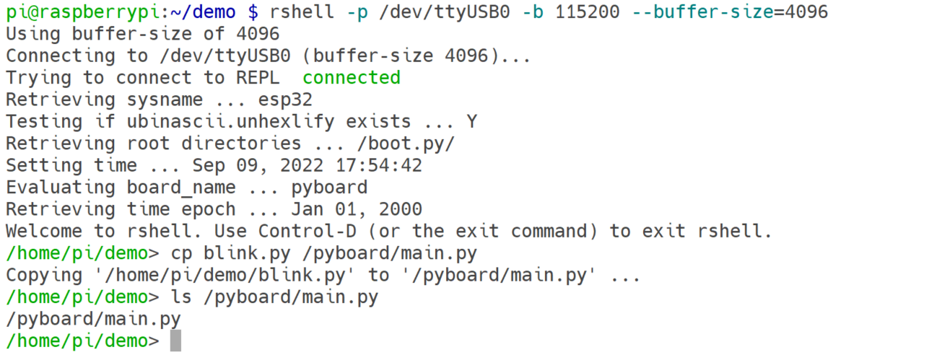

Input **repl** command to entering REPL. you can exit by press **CTRL+X**.

**repl**

**import main**

you can see the LED indicator is blinking.

Also you can upload other demo code that we have already shared on GitHub:

[**https://github.com/geeekpi/superkit**](https://github.com/geeekpi/superkit)

### Programming ESP32 Dev Board By using the ESP-IDF Environment

This document is intended to help you set up the software development environment for the hardware based on the ESP32 chip by Espressif. After that, a simple example will show you how to use ESP-IDF (Espressif IoT Development Framework) for menu configuration, then for building and flashing firmware onto an ESP32 board.

**Note**

This is documentation for the master branch (latest version) of ESP-IDF. This version is under continual development.

#### Introduction

ESP32 is a system on a chip that integrates the following features:

* Wi-Fi (2.4 GHz band)
* Bluetooth
* Dual high performance Xtensa® 32-bit LX6 CPU cores
* Ultra Low Power co-processor
* Multiple peripherals
* Powered by 40 nm technology, ESP32 provides a robust, highly integrated platform, which helps meet the continuous demands for efficient power usage, compact design, security, high performance, and reliability.
* Espressif provides basic hardware and software resources to help application developers realize their ideas using the ESP32 series hardware. The software development framework by Espressif is intended for development of Internet-of-Things (IoT) applications with Wi-Fi, Bluetooth, power management and several other system features.

#### What You Need

##### Hardware

* An ESP32 board.
* USB cable - USB A / micro USB B.
* Computer running Windows, Linux, or macOS.

##### Software

To start using ESP-IDF on ESP32, install the following software:

* Toolchain to compile code for ESP32
* Build tools - CMake and Ninja to build a full Application for ESP32
* ESP-IDF that essentially contains API (software libraries and source code) for ESP32 and scripts to operate the Toolchain

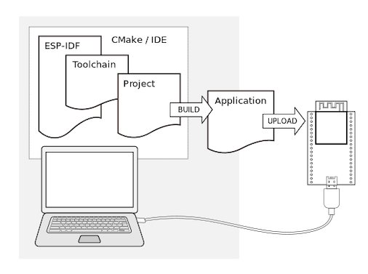

#### Installation

To install all the required software, we offer some different ways to facilitate this task. Choose from one of the available options.

#### IDE

**Note**

We highly recommend installing the ESP-IDF through your favorite IDE.

#### Eclipse Plugin:

https://github.com/espressif/idf-eclipse-plugin/blob/master/README.md

#### VSCode Extension:

https://github.com/espressif/vscode-esp-idf-extension/blob/master/docs/tutorial/install.md

##### Manual Installation

For the manual procedure, please select according to your operating system.

* Windows Installer: <https://docs.espressif.com/projects/esp-idf/en/latest/esp32/get-started/windows-setup.html>
* Linux and macOS: <https://docs.espressif.com/projects/esp-idf/en/latest/esp32/get-started/linux-macos-setup.html>

#### Build Your First Project

If you already have the ESP-IDF installed and not using IDE, you can build your first project from the command line following the

#### Start a Project on Windows:

https://docs.espressif.com/projects/esp-idf/en/latest/esp32/get-started/windows-setup.html#get-started-windows-first-steps

#### Start a Project on Linux and macOS:

https://docs.espressif.com/projects/esp-idf/en/latest/esp32/get-started/linux-macos-setup.html#get-started-linux-macos-first-steps

Now you are ready to try some other examples, or go straight to developing your own applications.

### Try examples with the sensors inside the package

#### Project description

|  |  |  |
| --- | --- | --- |
| Project Name | Hardware | Description |
| adc | rotary joystick | It is powered by 3V3, the default is to use **GPIO34** for sampling, download and run, then open the Monitor to observe the data, and adjust the knob data changes. |
| mpu6050 | MPU6050 module | **SDA = IO18, SCL = IO19**, download and run to open the Monitor observation data. |
| oled | SSD1306 module | LVGL library porting and demonstration, default **SDA = 5, SCL = 4**, you need to modify the undefined part in the ssd1306.c file, and check the error prompt of the first compilation in detail. |
| Servo | Servo | Download and run, you can see that the servo moves back and forth, **CH0 (IO32)** is used by default. |
| stepper | Stepper motor and drive module | Download and run, you can see the single-direction movement of the stepper motor, the default use of **IN0 (IO27), IN1 (IO26), IN2 (IO25), IN3 (IO33).** |
| Ultrasonic | ultrasonic SR04 | download and run and open the Monitor to observe the measured values. By default, **TRIG (IO27) and ECHO (IO26)** are used. |
| ws2812 | WS281x | Download and run the observation effect, connect to **IO18** by default, limited by RMT peripherals, IO cannot be modified casually. |

##### 1.Downalod and Install Visual Studio Code

<https://code.visualstudio.com/download>

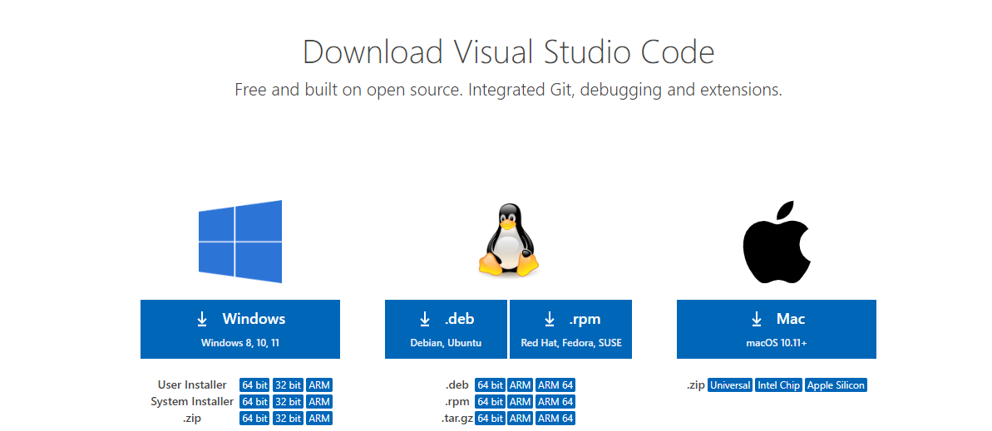

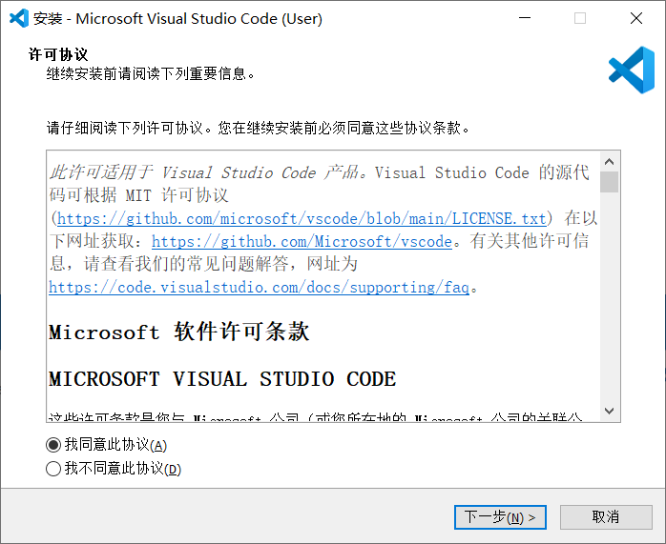

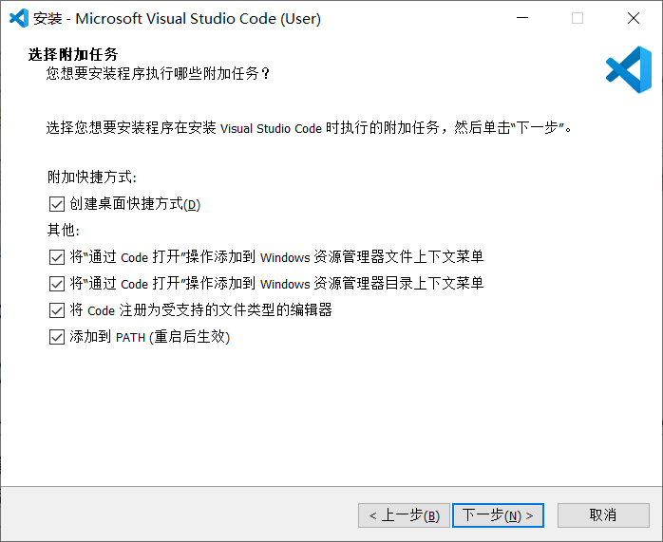

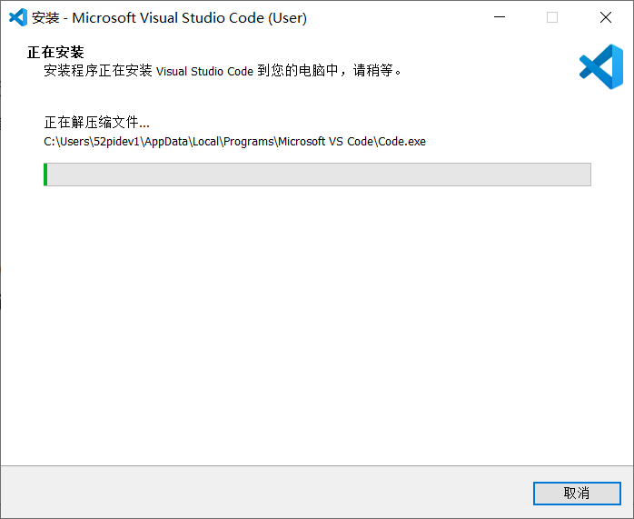

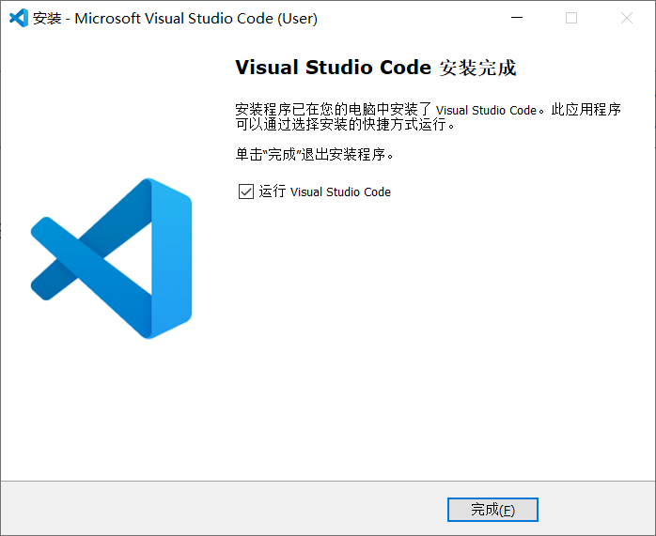

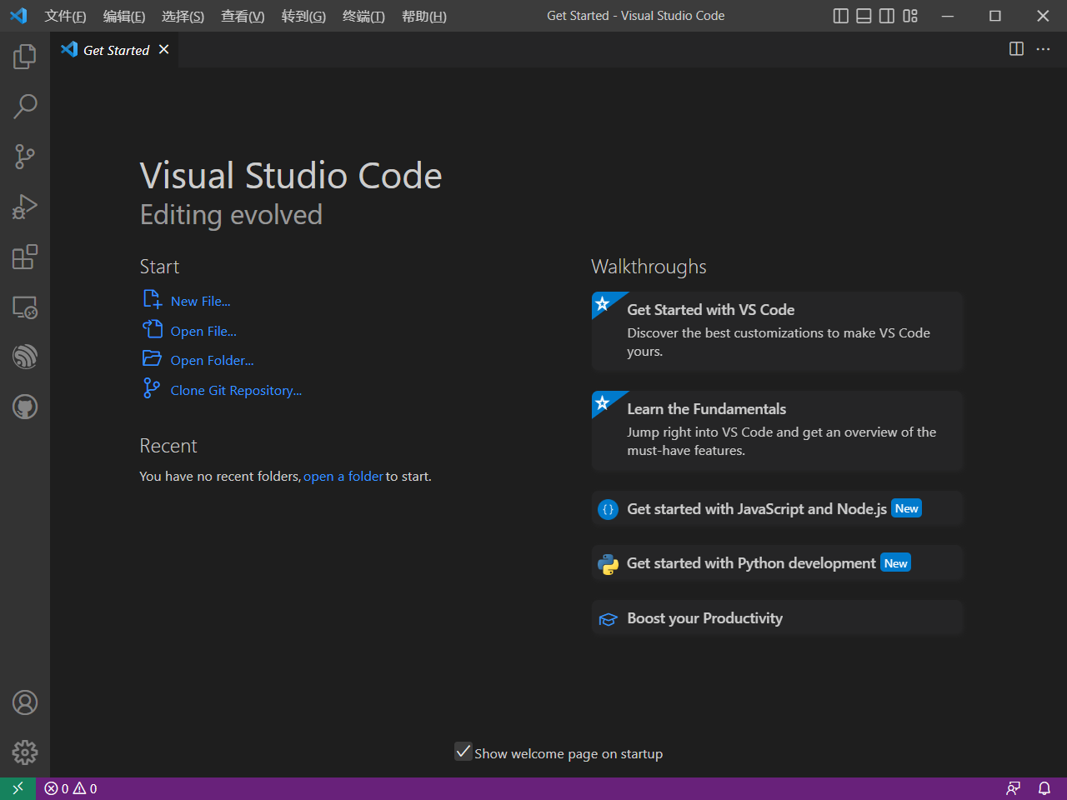

#### 2. Clone demo code to local machine. (It is very Important)

##### 

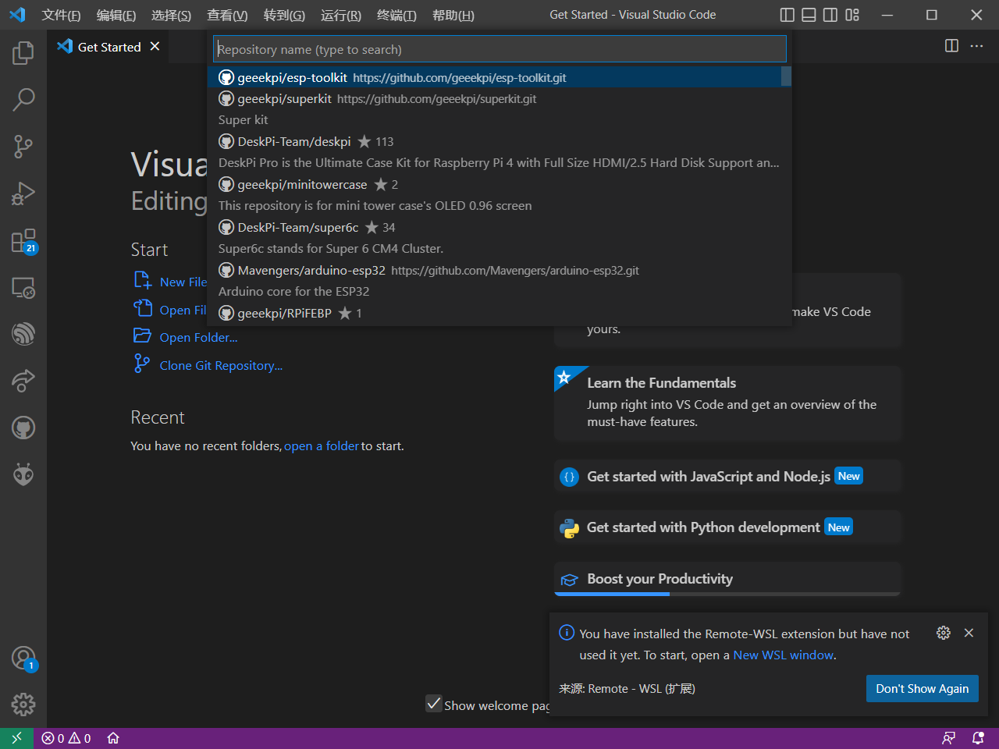

clone the repository from: <https://github.com/geeekpi/esp-toolkit.git>

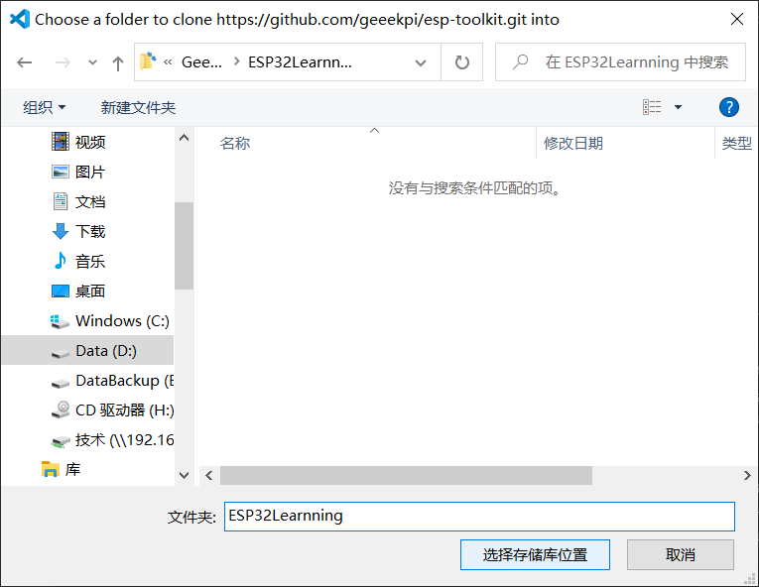

**select a folder to store the repository.**

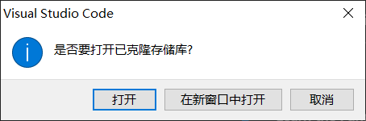

**click open.**

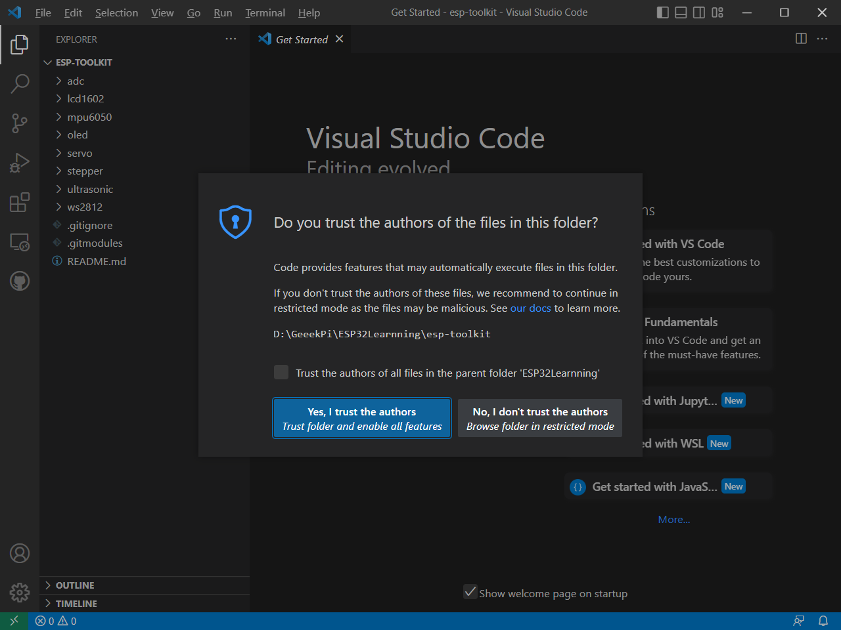

**select “yes, I trust the authors.”**

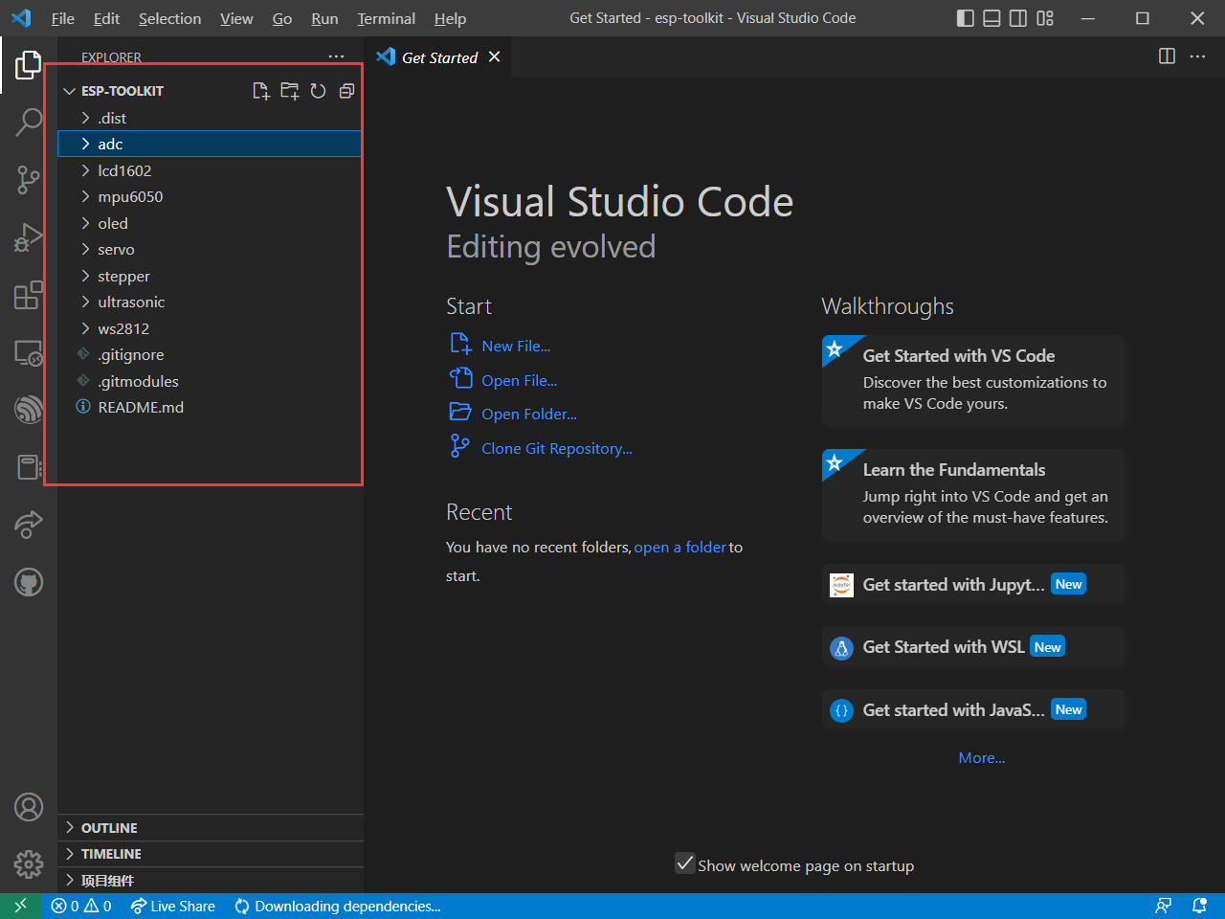

**Here will be the demo projects.**

**Follow this link to install dependencies.**

[**https://github.com/espressif/vscode-esp-idf-extension/blob/master/docs/tutorial/install.md**](https://github.com/espressif/vscode-esp-idf-extension/blob/master/docs/tutorial/install.md)

**Open the Extensions view by clicking on the Extension icon in the Activity Bar on the side of Visual Studio Code or the View: Extensions command ⇧ ⌘ X.**

**Search the extension with any related keyword like Espressif, esp-idf, esp32, esp32s2, etc.**

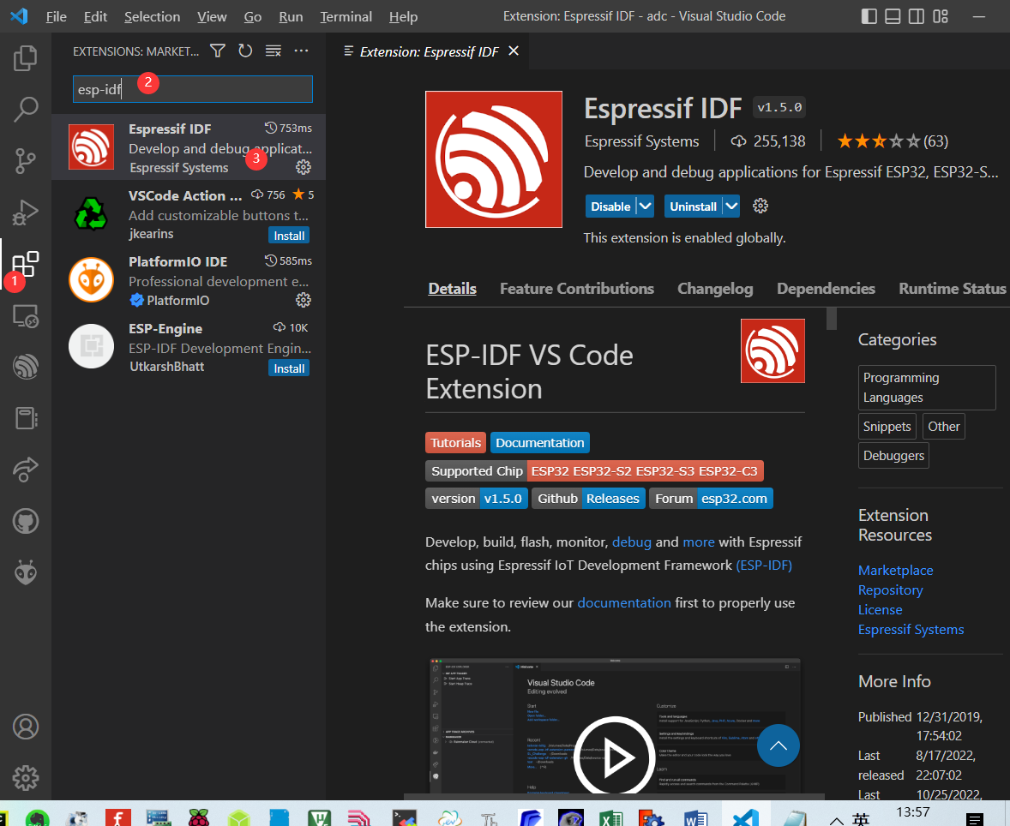

#### Install the extension

**Install ESP-IDF Prerequisites and, if using WSL2, the required packages specified in WSL Documentation.**

**Press F1 and type ESP-IDF: Select where to save configuration settings, which can be User settings, Workspace settings or workspace folder settings.**

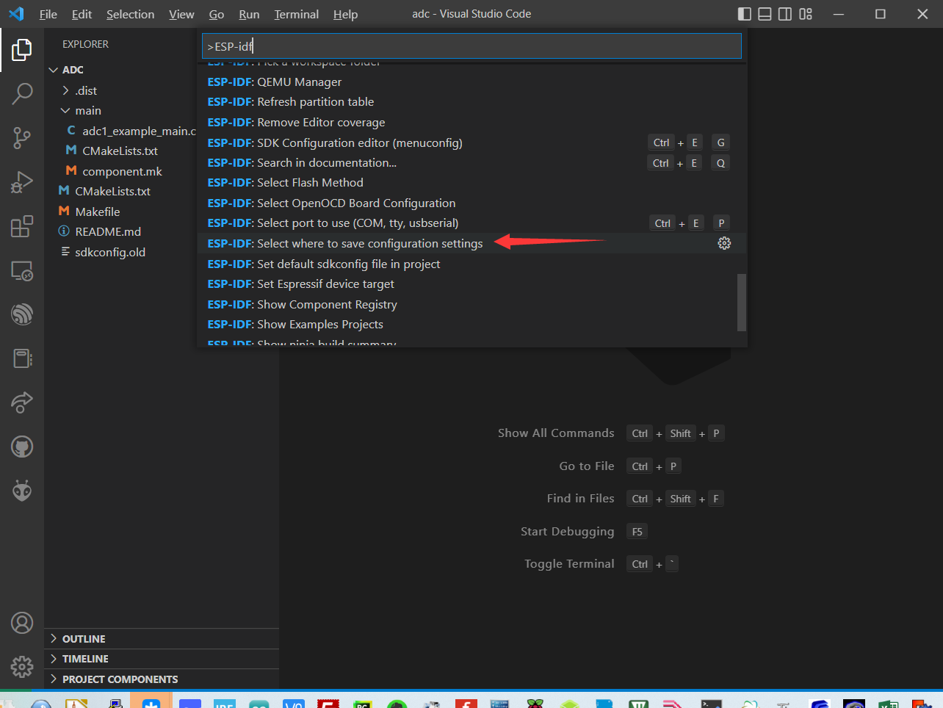

**Please take a look at Working with multiple projects for more information. Default is User settings.**

**In Visual Studio Code, select menu "View" and "Command Palette" and type [configure esp-idf extension]. After, choose the ESP-IDF: Configure ESP-IDF extension option.**

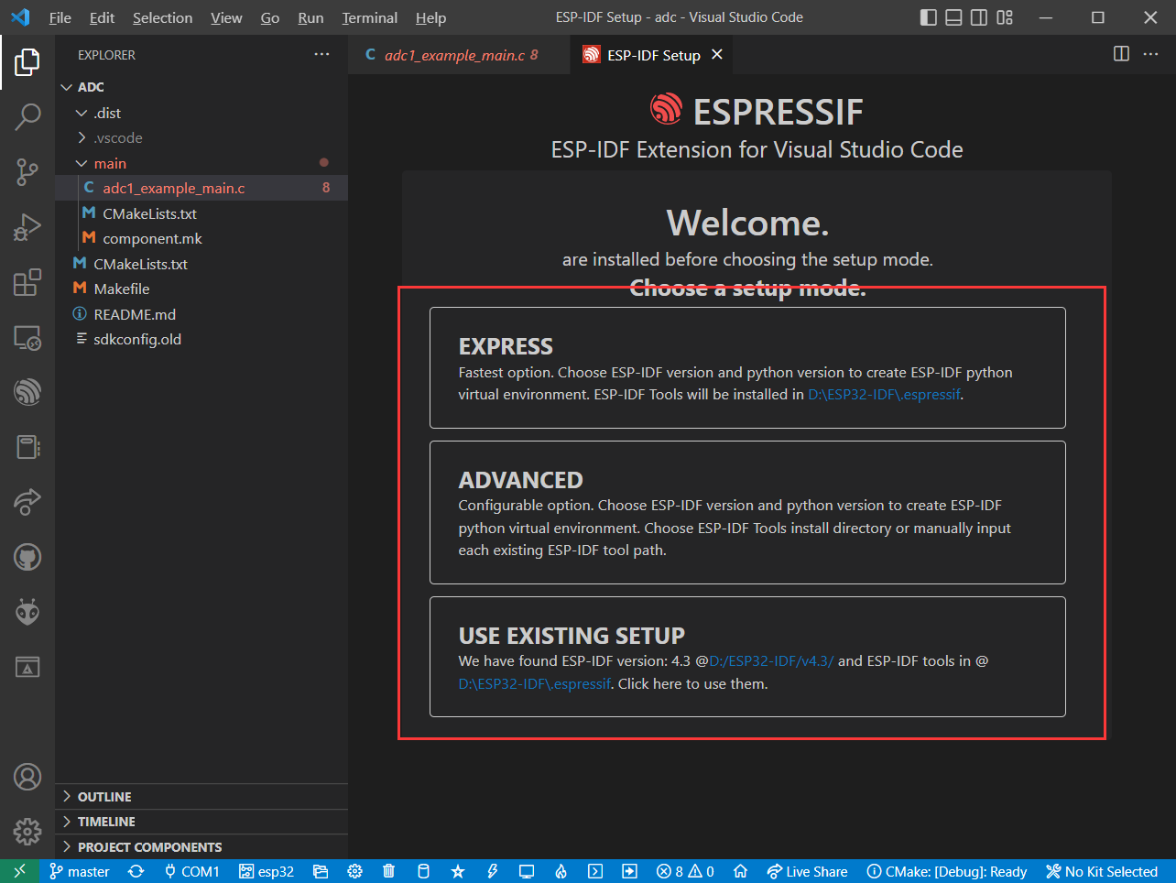

**Now the setup wizard window will be shown with several setup options: Express, Advanced or Use existing setup.**

**Select following parameters as you wish.**

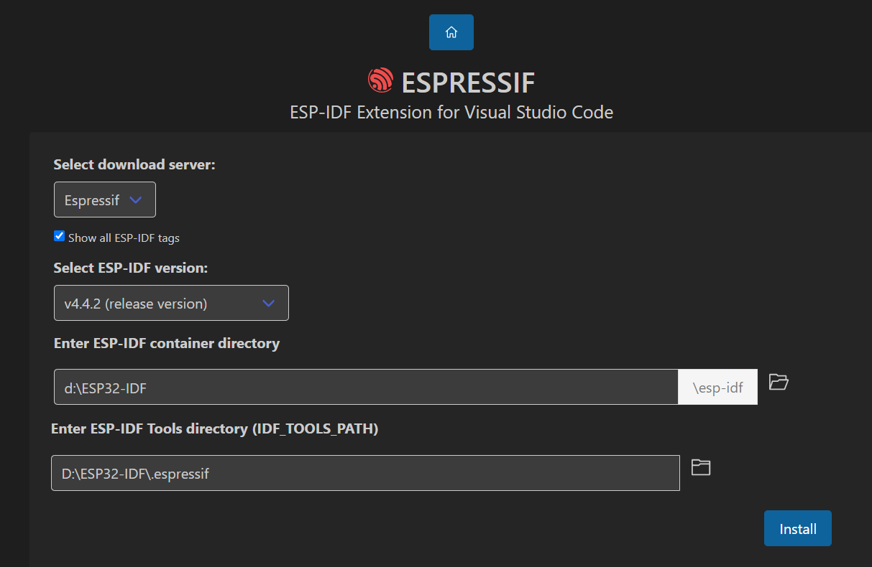

**and then click install and waiting for a while.**

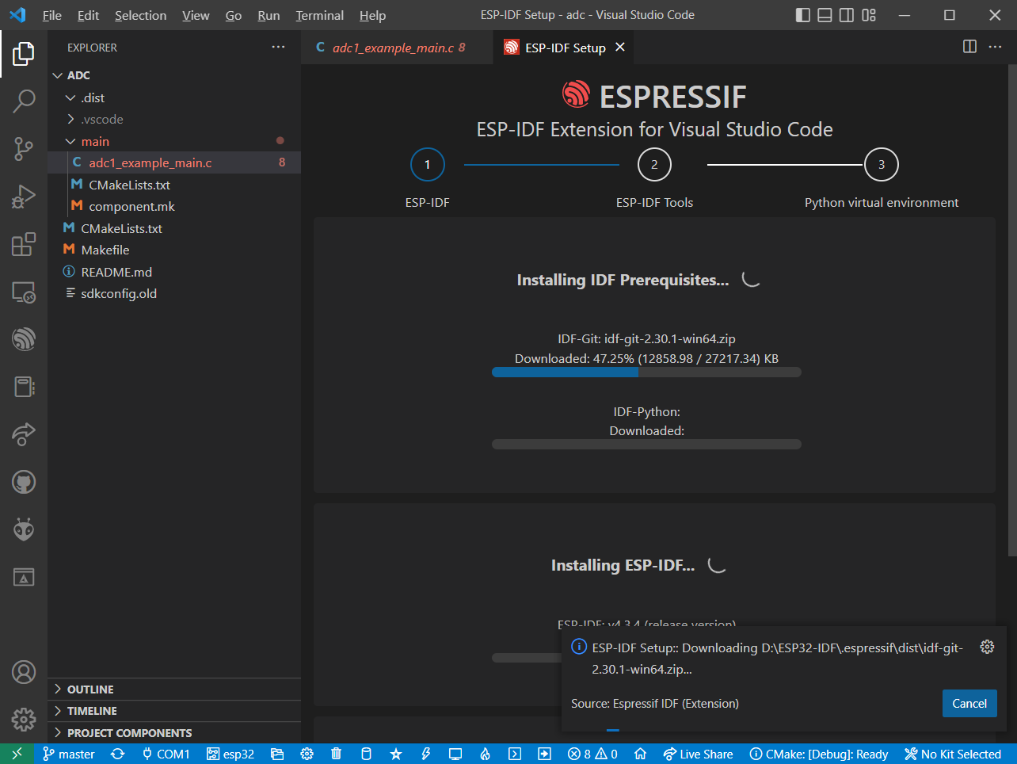

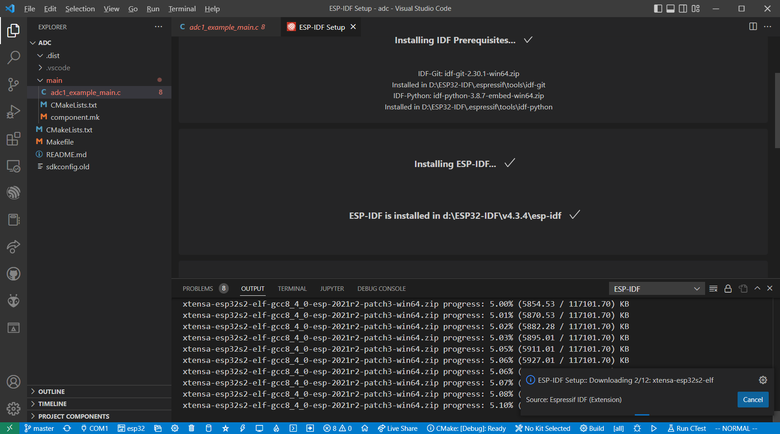

**until you see:**

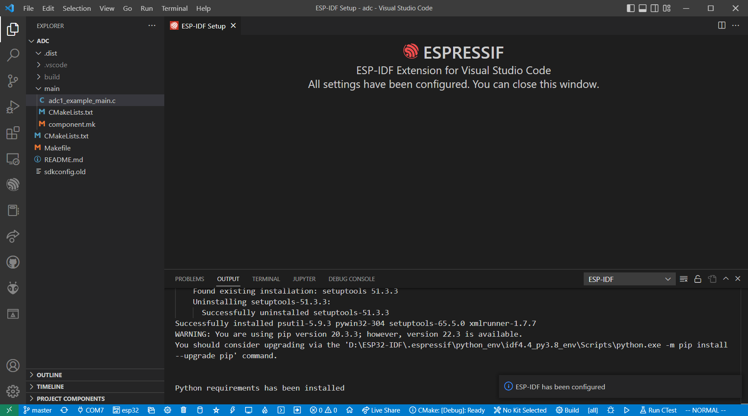

**Connect ESP32 to PC by using MicroUSB cable, and select serial port. The port number will be different, just select the one which is popped up.**

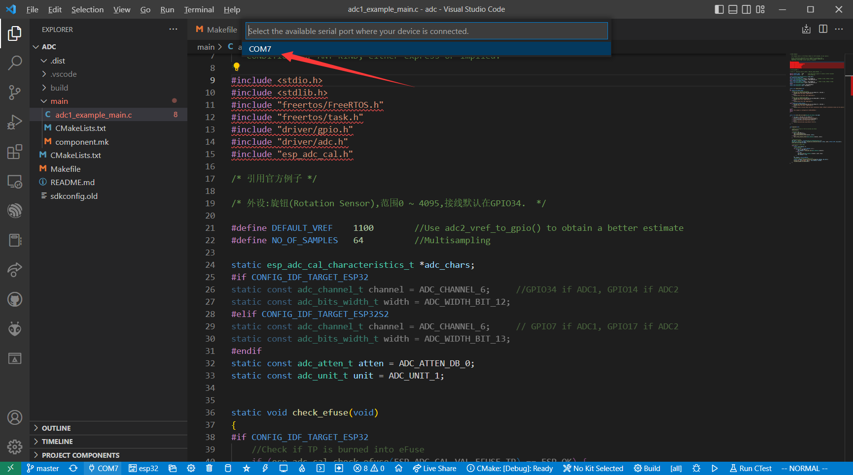

**and then select target to esp32**

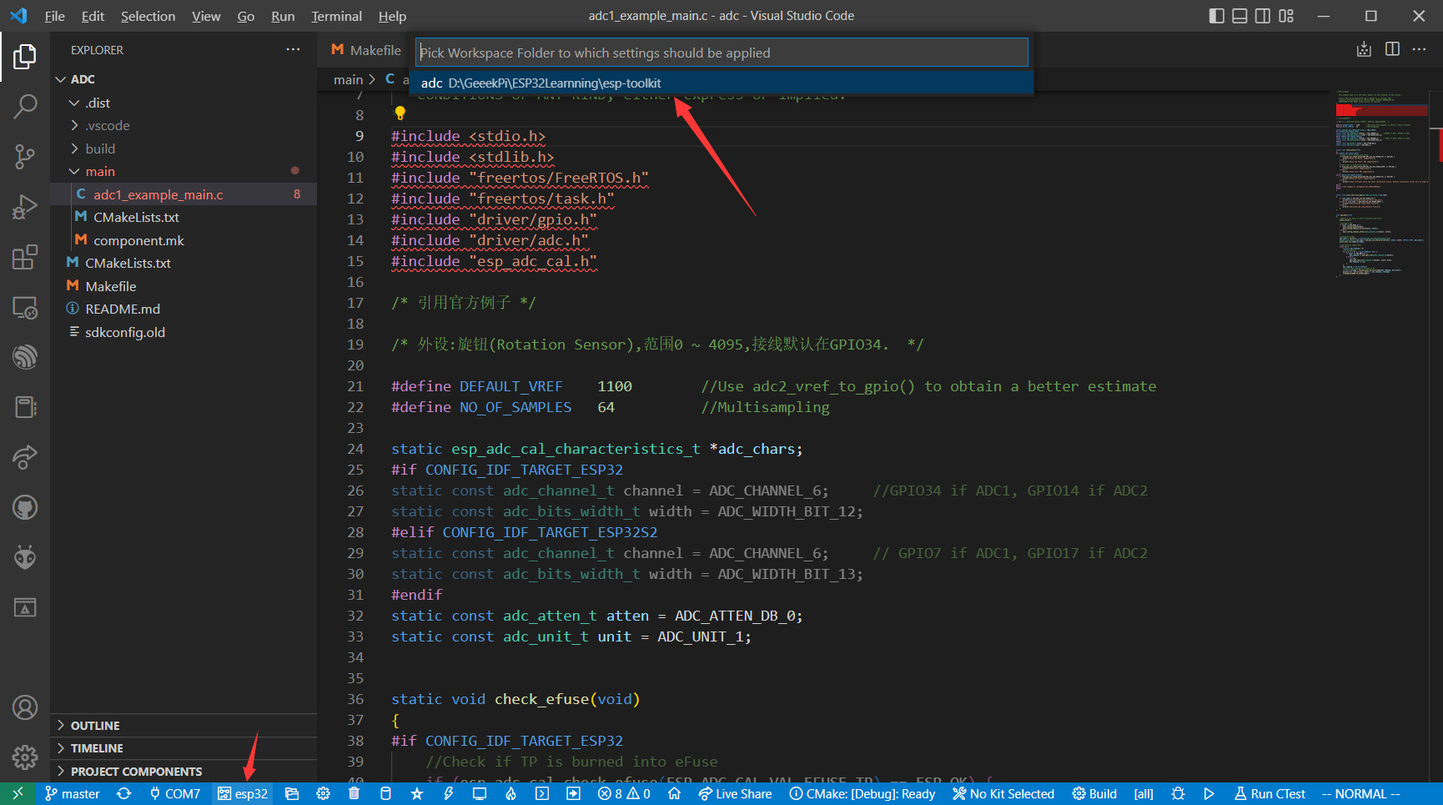

**and then click ESP-IDF build project**

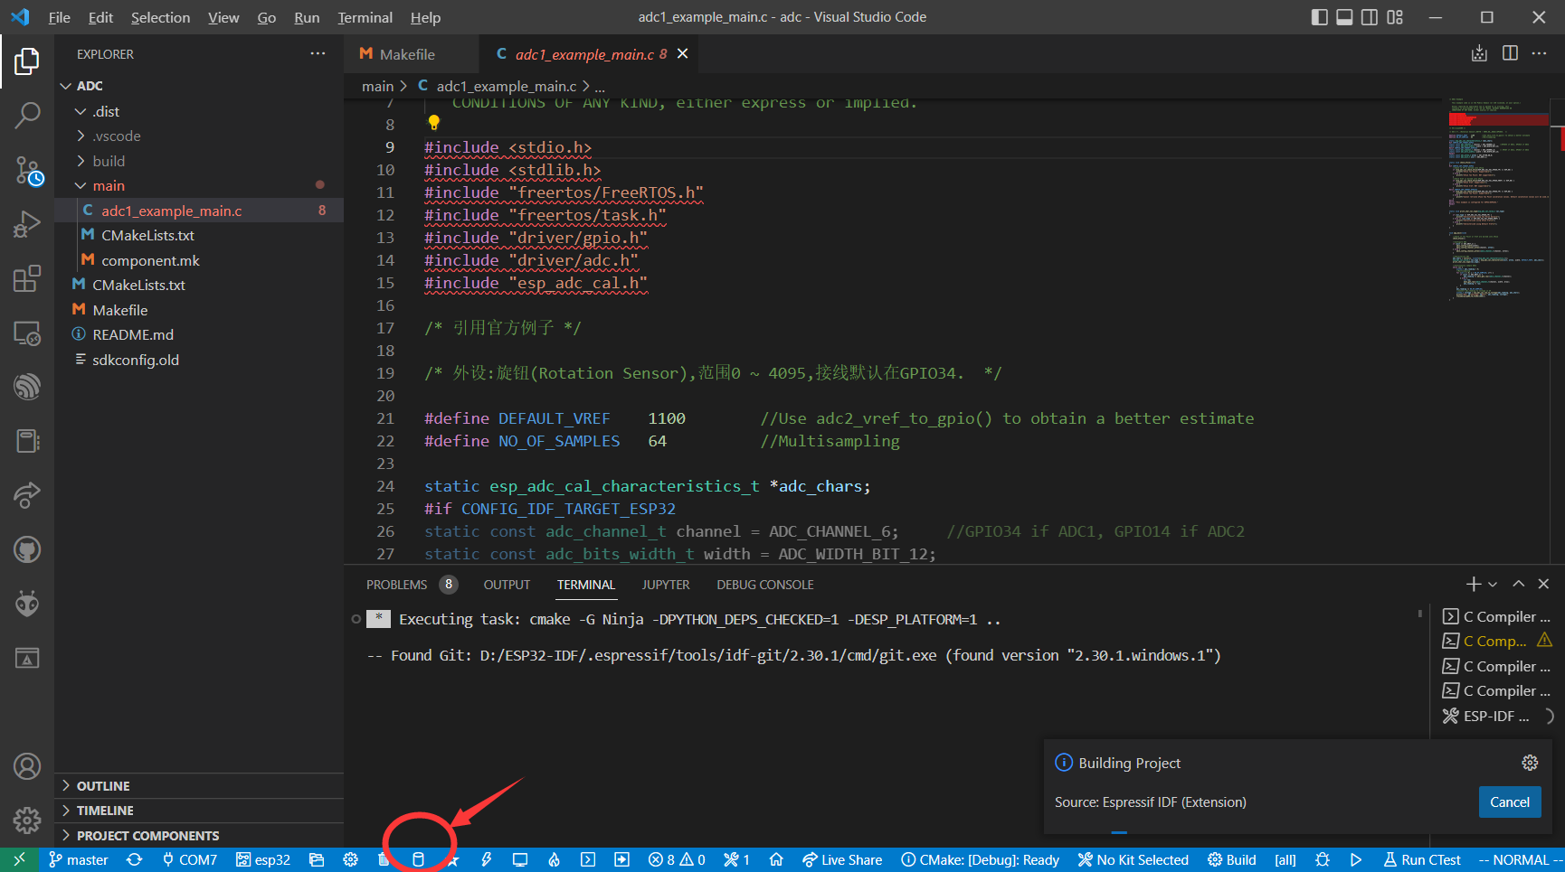

**waiting for it finished.**

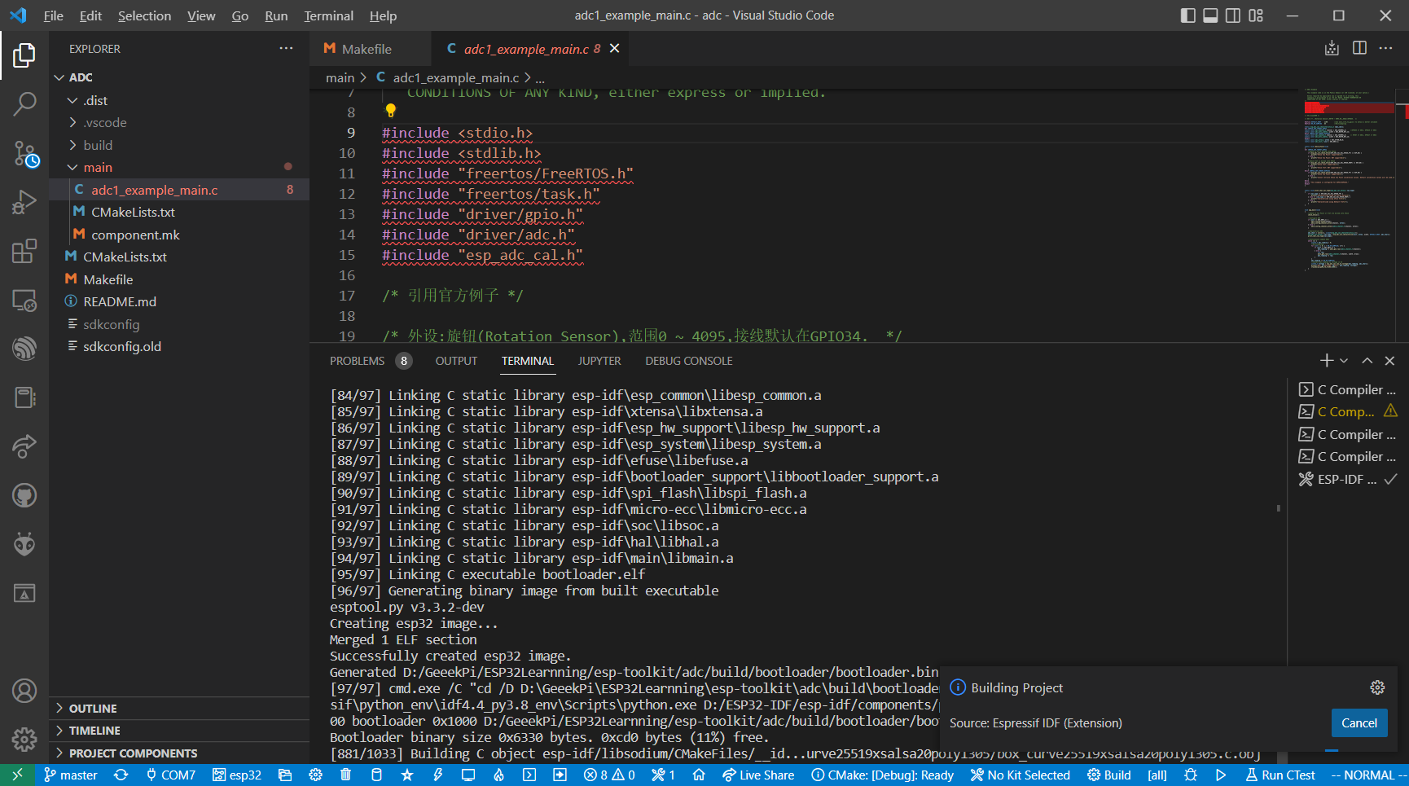

**flash it to ESP32:**

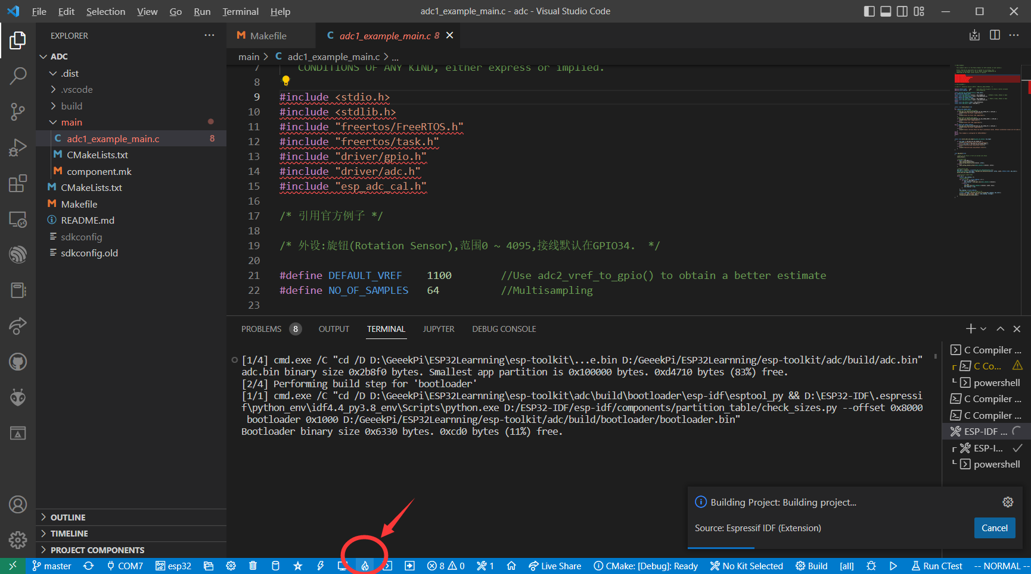

**select flash mode to UART**

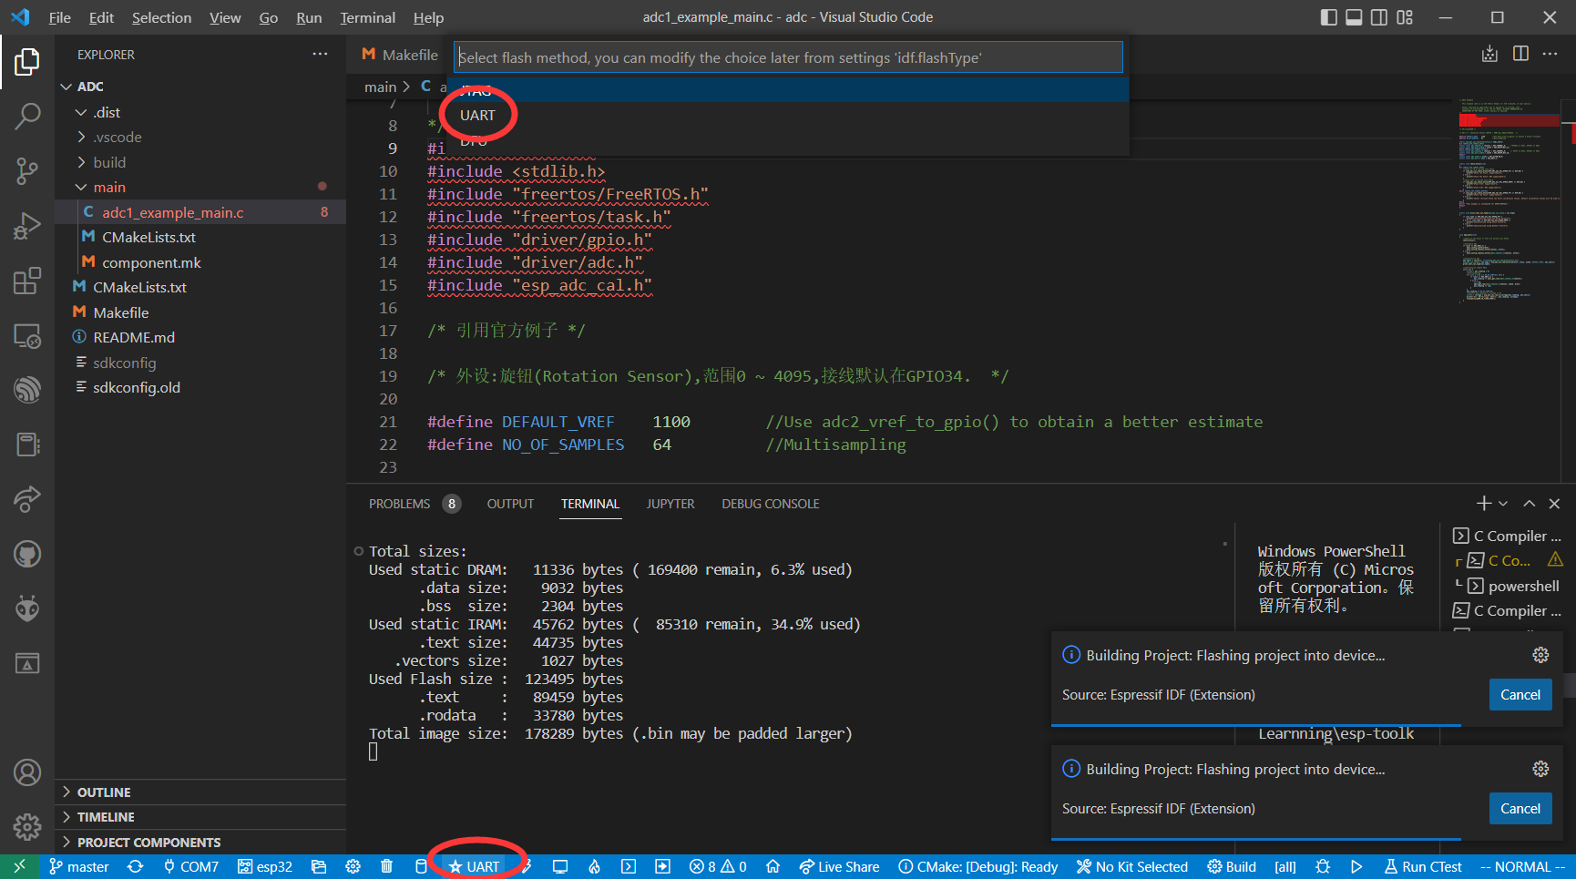

**click flash and monitor:**

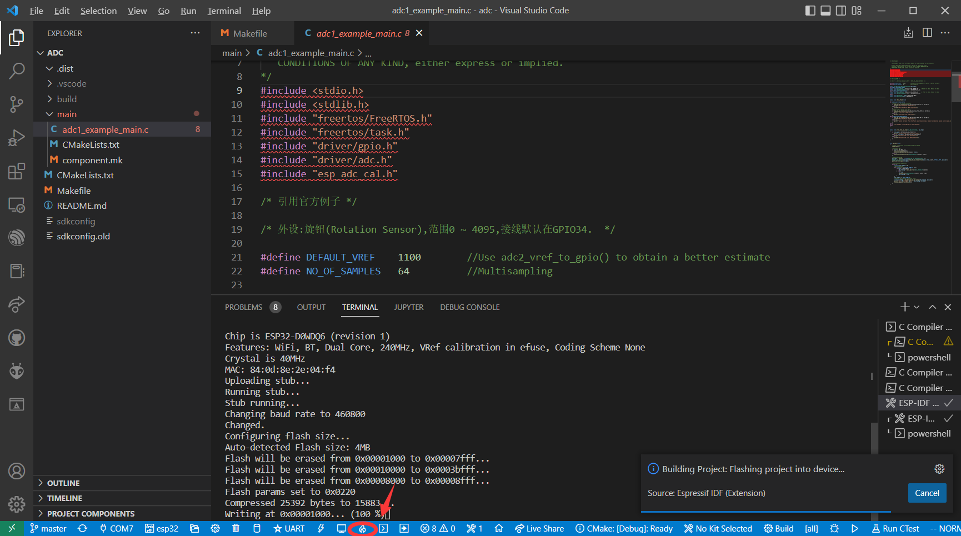

**In this project, you will see ADC (analog digital Converter) detection result.**

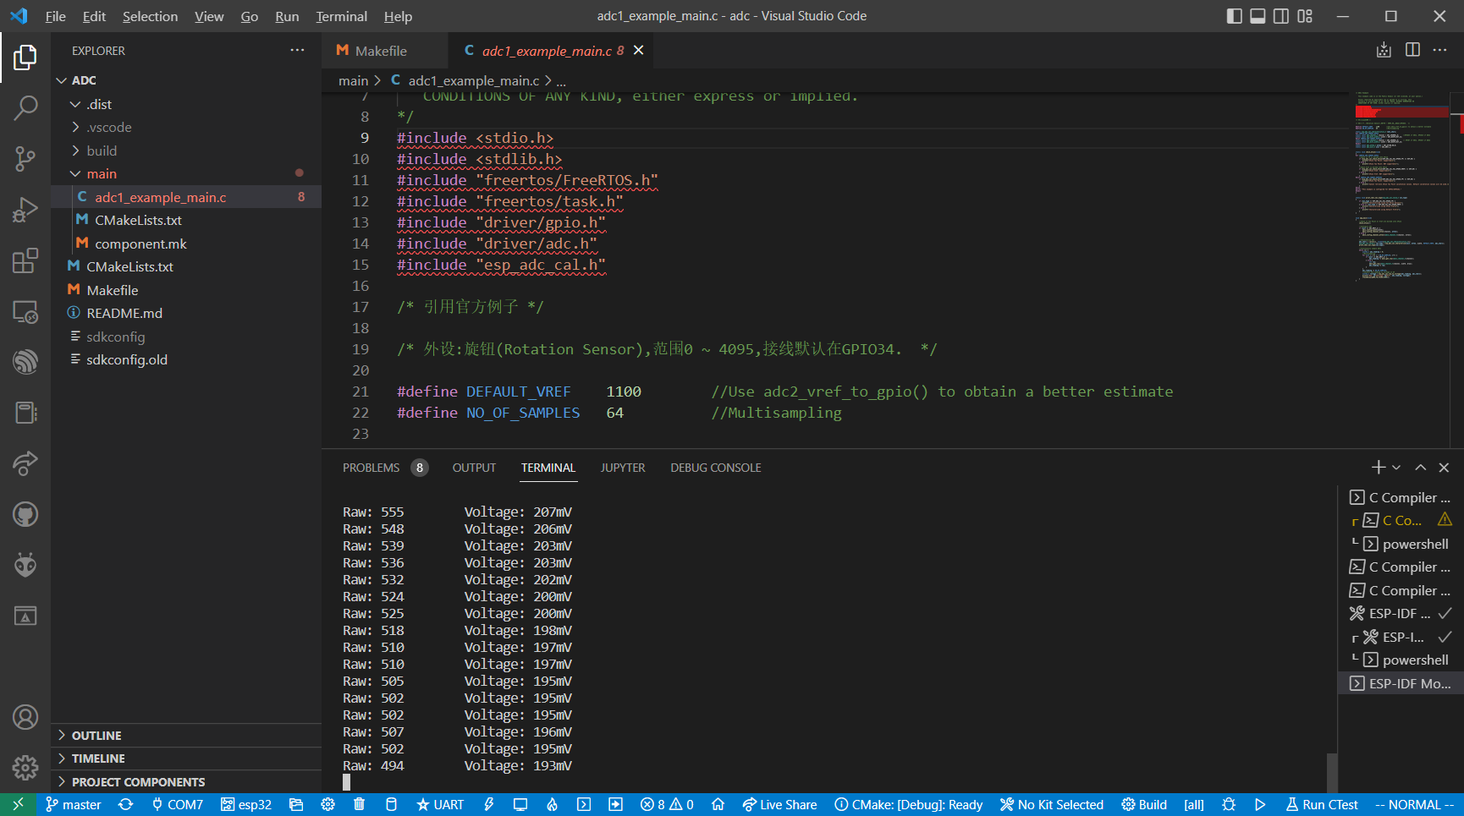

**Unplug the MicroUSB cable and build your own circuit on breadboard.**

**Next is to wiring the circuit, before that, you need to read the readme.md file to figure out the connection details, and you also can modify the circuit as you wish.**

### ADC

**for example, the ADC project is to read the analogue data from a potentiometer, you can wire the potentiometer and ESP32 WROVER module as following chart:**

|  |  |
| --- | --- |
| **ESP32 WROVER module** | **Potentiometer** |
| **3V3** | **VCC** |
| **GND** | **GND** |
| **GPIO34** | **OUT** |

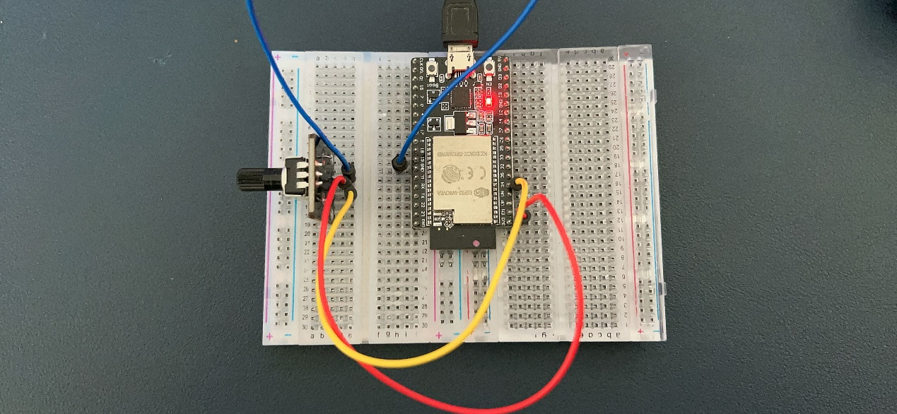

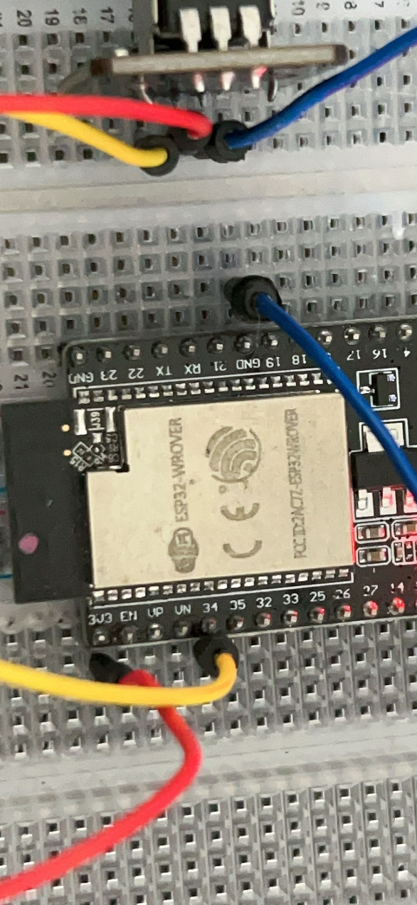

**and then you rotate potentiometer, the information will show on the monitor.**

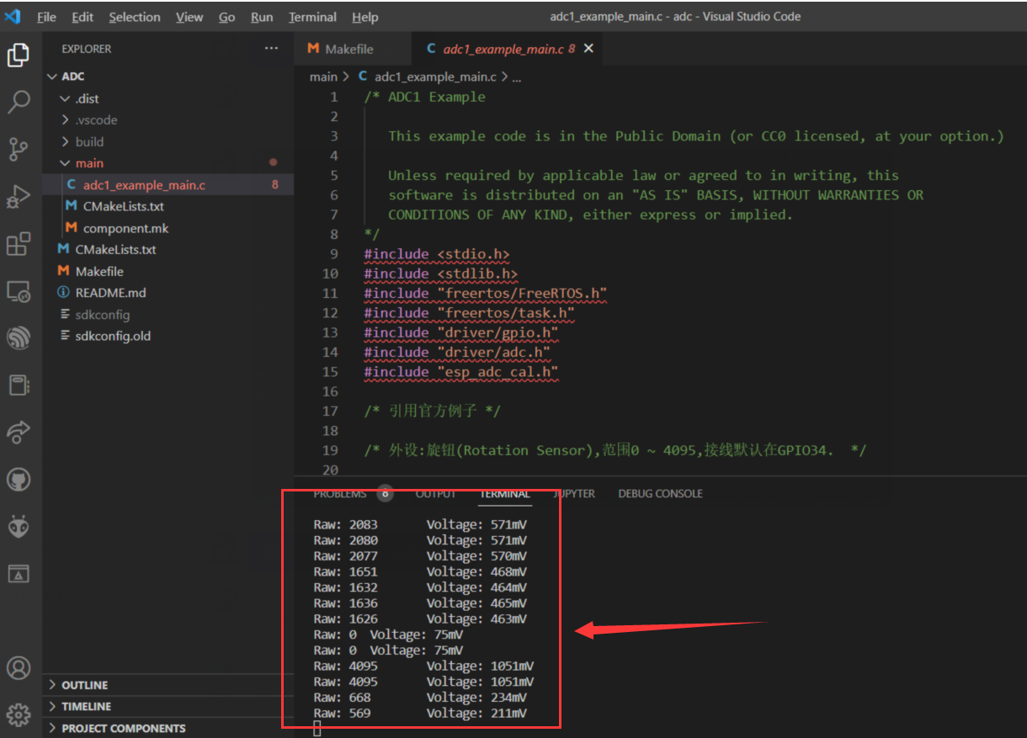

**Next let us try Servo.**

### Servo

#### wiring:

|  |  |
| --- | --- |
| **ESP32 WROVER module** | **Servo** |
| **5V** | **Red wire** |
| **GND** | **Brown wire** |
| **CH0 (IO32)** | **Yellow wire** |

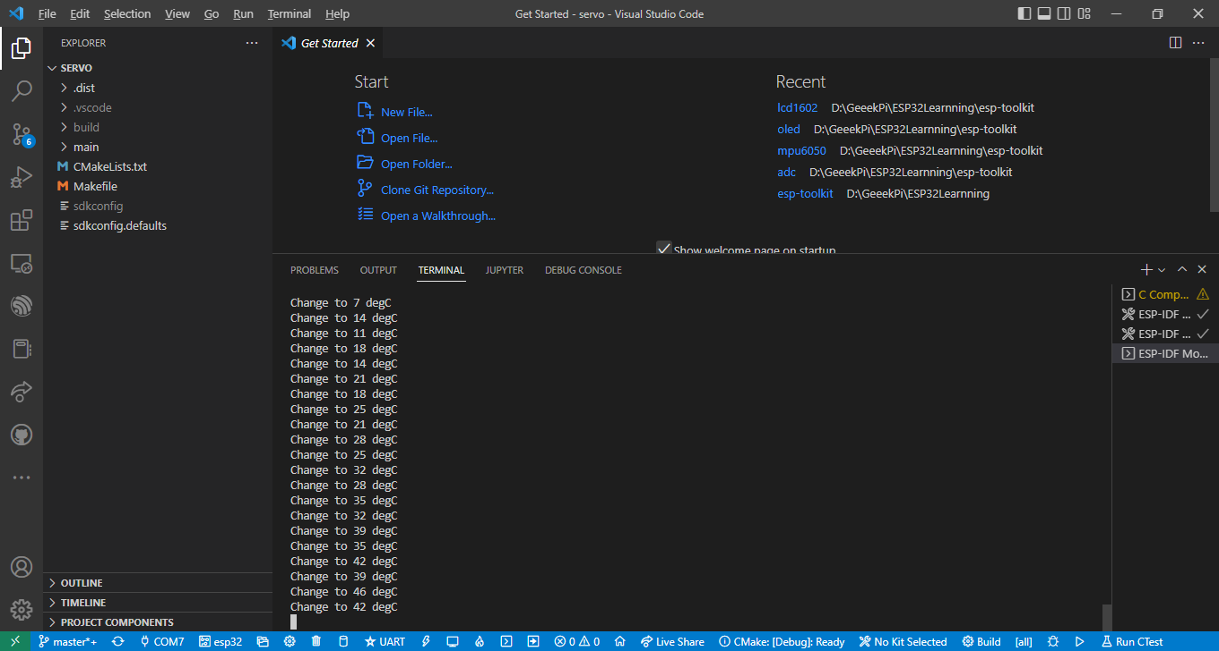

#### Ultrasonic sensor

##### Wiring:

|  |  |
| --- | --- |
| **ESP32 WROVER module** | **Ultrasonic sensor** |
| **5V** | **VCC** |
| **GND** | **GND** |
| **IO27** | **TRIG** |
| **IO26** | **ECHO** |

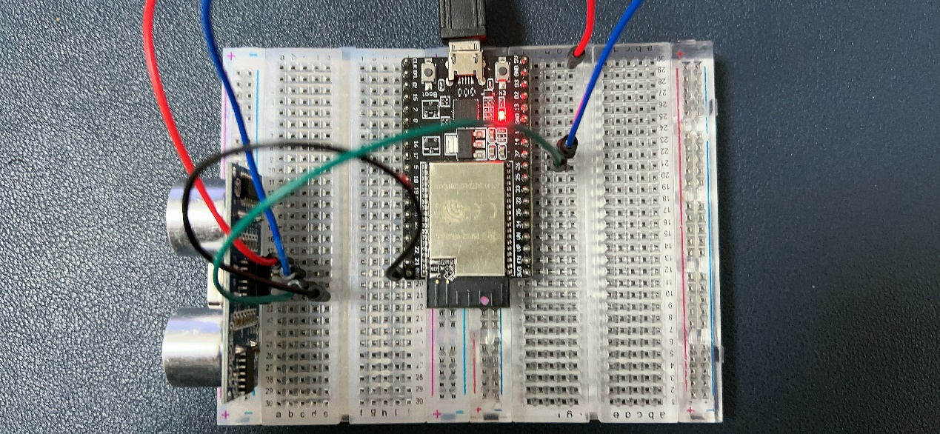

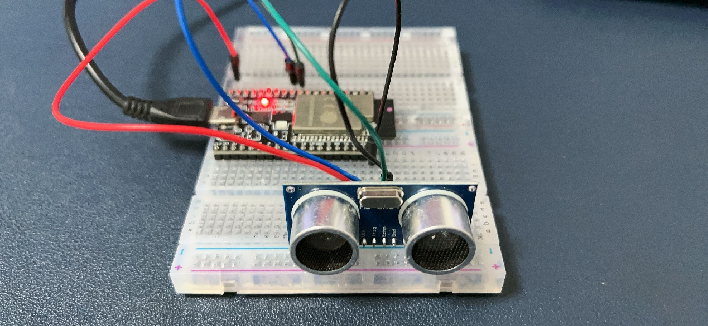

**Please pay attention to this step, once you open a new project, after click the “ESP-IDF set device target” 🡪 Please select ESP32 🡪 ESP32 chip(via USB Bridge)**

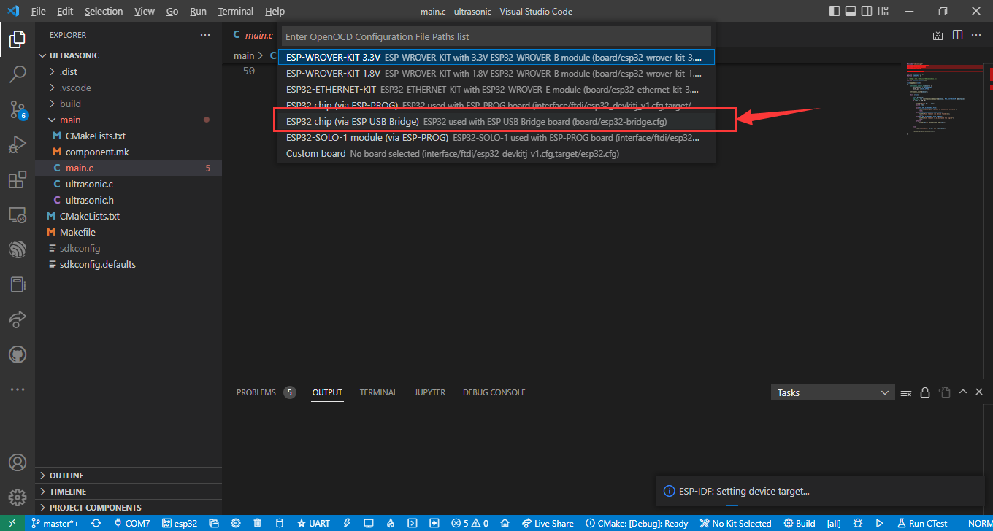

**after setting, click build flash and monitor icon on the bottom of bar.**

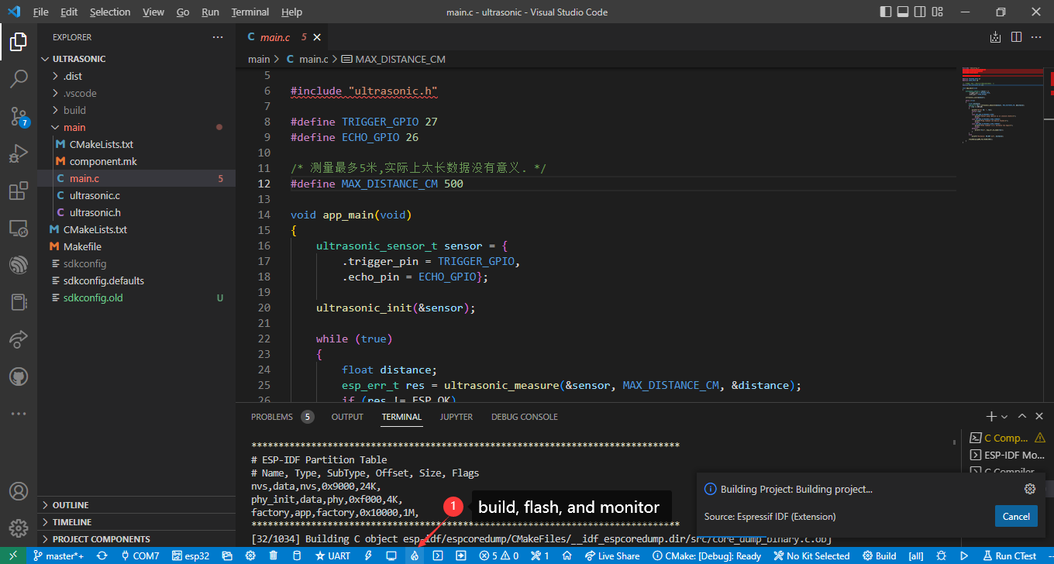

**After compiling and flashing, it will open a monitor automatically.**

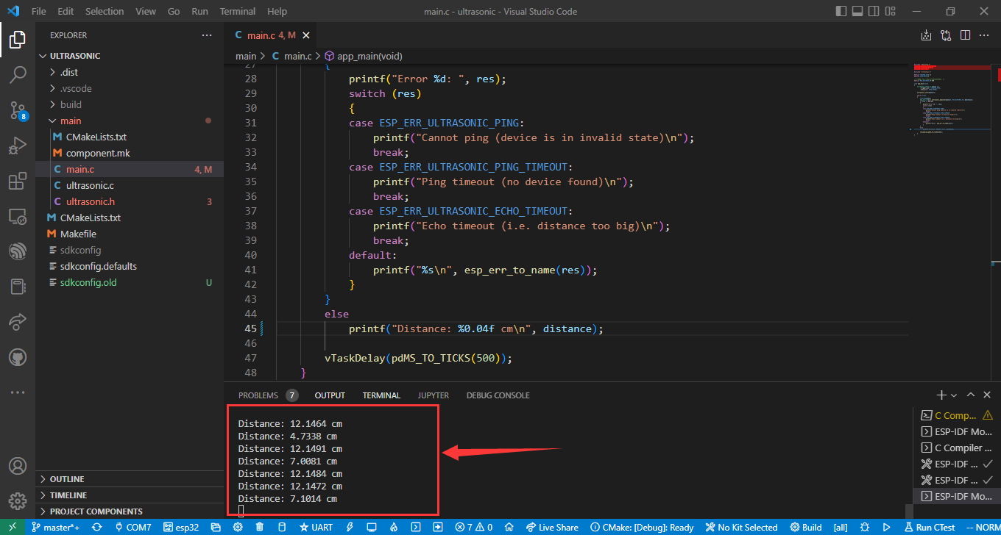

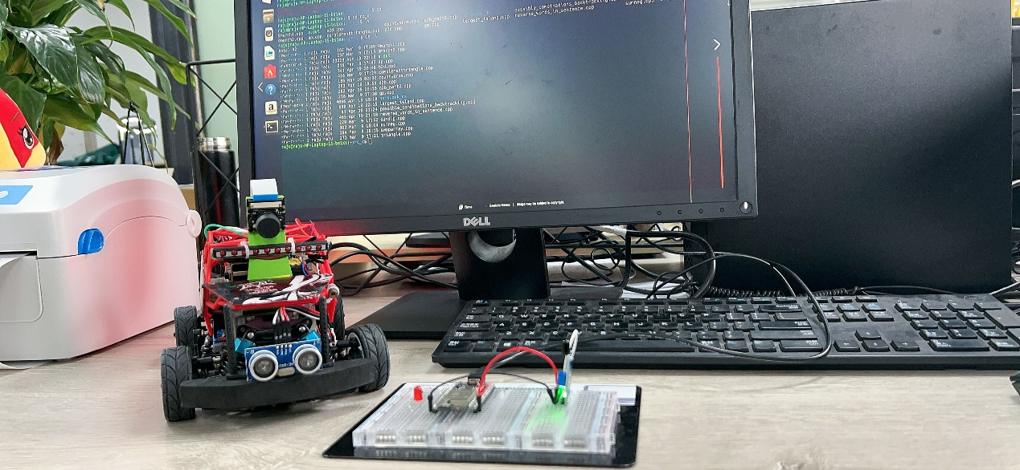

### MPU6050

#### Wiring:

|  |  |
| --- | --- |
| **ESP32 WROVER module** | **MPU6050 module** |
| **3V3** | **VCC** |
| **GND** | **GND** |
| **IO18** | **SDA** |
| **IO19** | **SCL** |

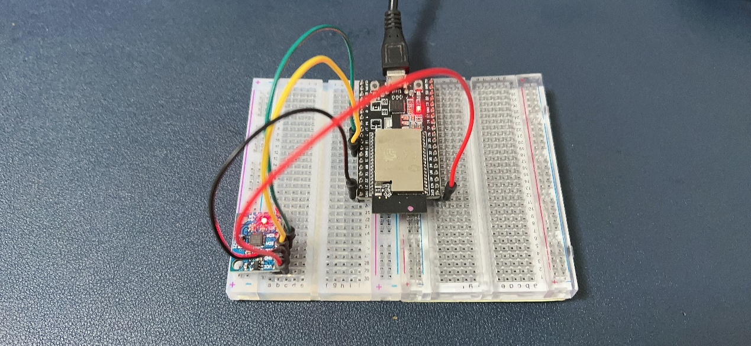

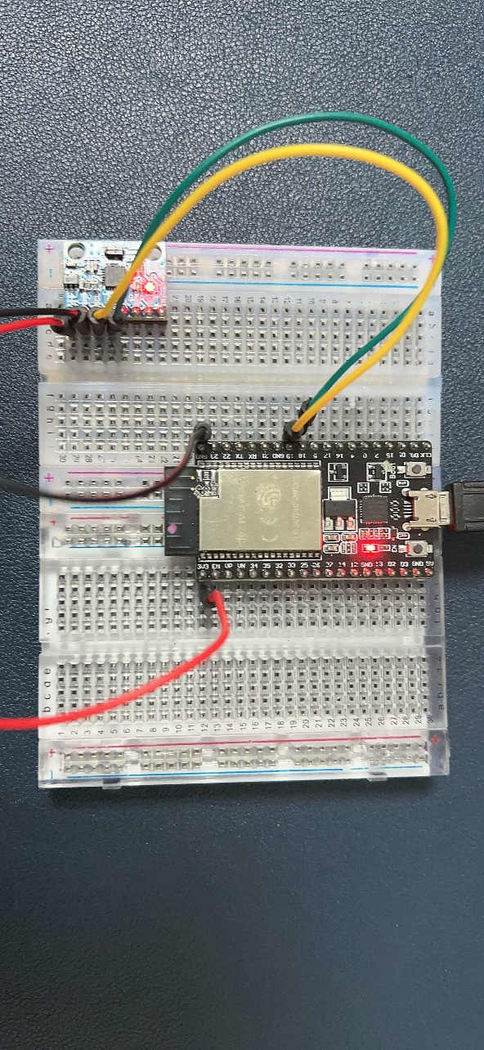

Open project via visual studio code IDE and then select serial port, device target and build the project, flash it and start monitor.

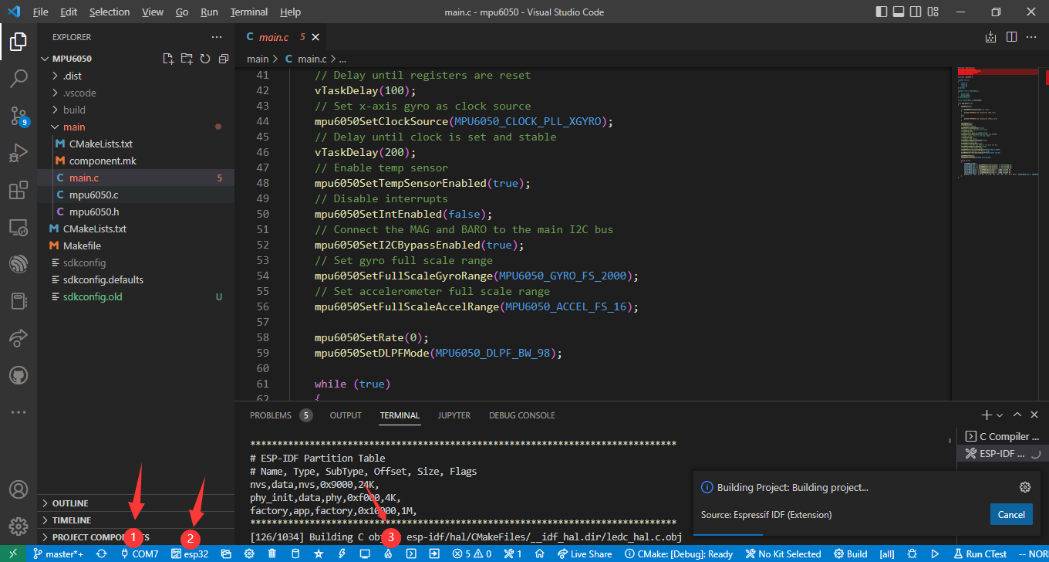

during flashing process, it will pop up a box, select UART and waiting for it flashing.

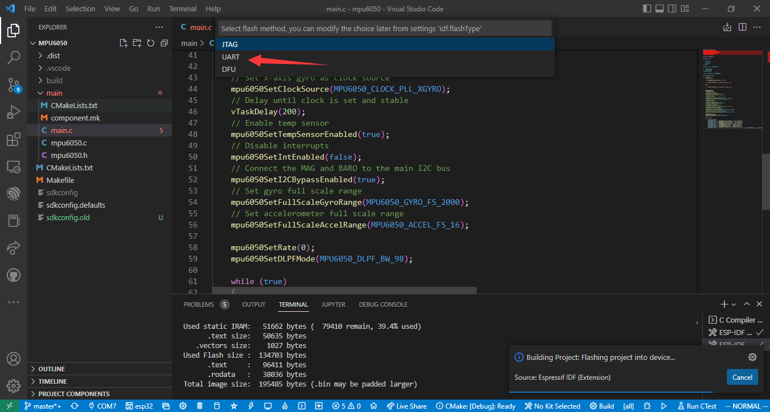After flashing, it will open monitor and reset the esp32, you will get the data from MPU6050 sensor.

### Stepper Motor

#### Wiring:

|  |  |
| --- | --- |
| **ESP32 WROVER module** | **Stepper motor Driver Board** |
| **5V** | **5V** |
| **GND** | **GND** |
| **IO27** | **IN1** |
| **IO26** | **IN2** |
| **IO25** | **IN3** |
| **IO33** | **IN4** |

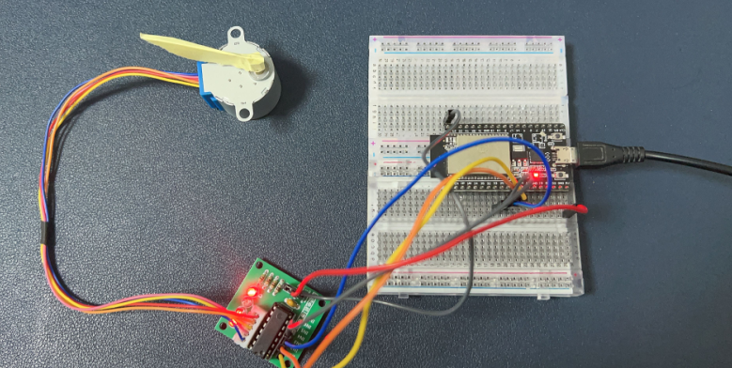

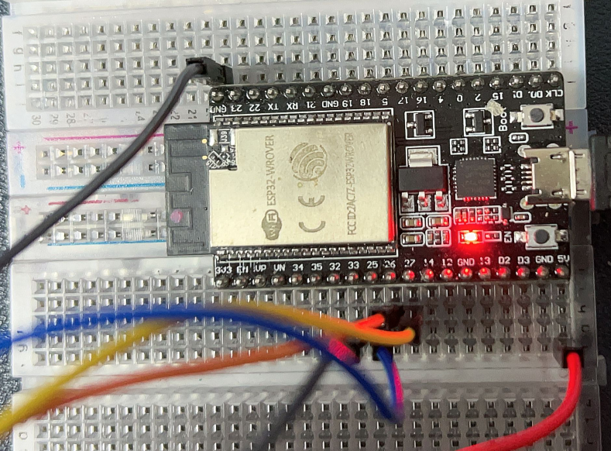

NOTE:

Sometimes, the USB port of the computer cannot provide enough current to drive the stepper motor, please connect the external power supply, and make the external power supply and ESP32 share common ground.

If you want to change the speed of stepper motor, you can change the number of vTaskDelay(10 / portTICK_PERIOD_MS); and build again, flash it to ESP32 and try again.

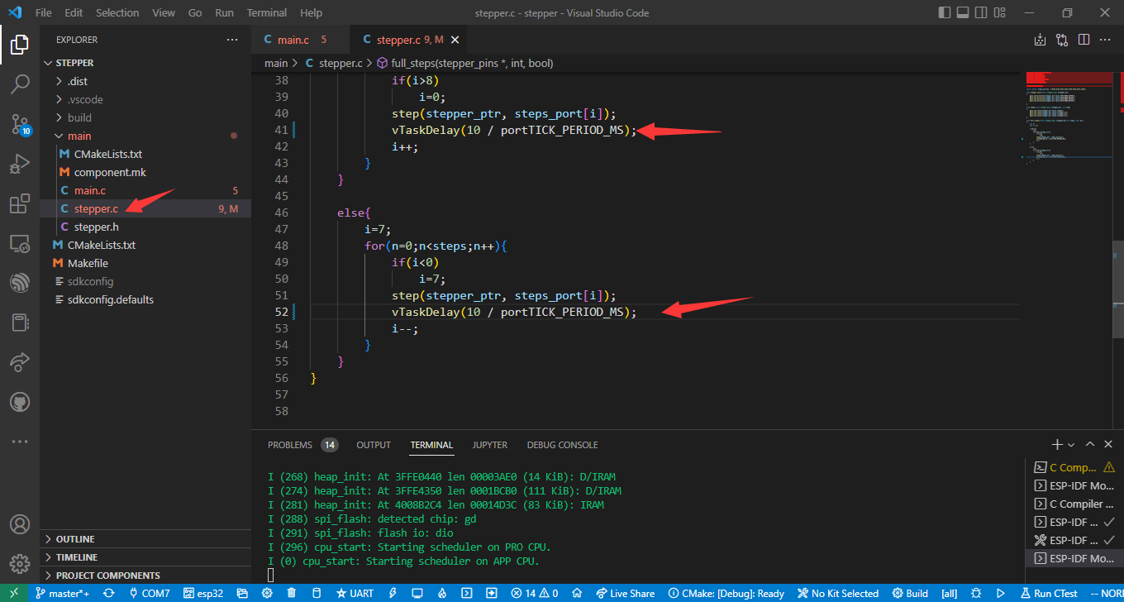

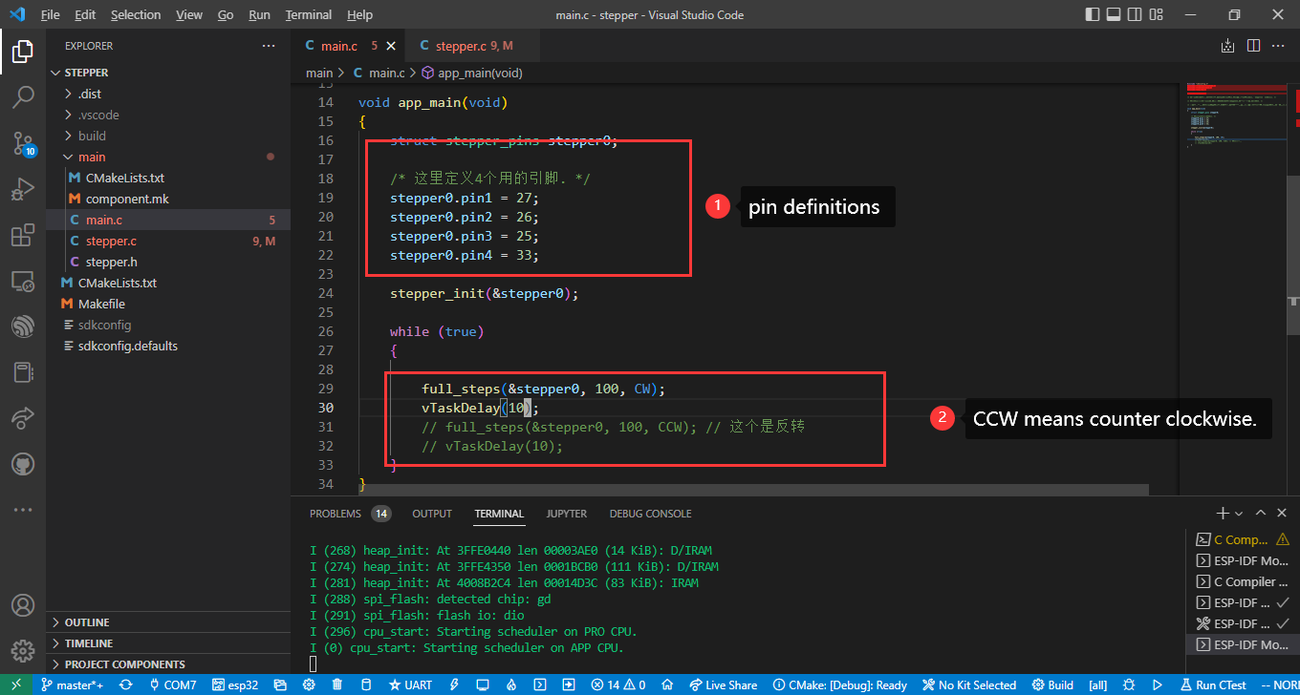

### WS2812 Neopixel Strip

#### Wiring:

|  |  |
| --- | --- |
| **ESP32 WROVER module** | **WS2812 Neopixel Strip** |
| **5V** | **+5V** |
| **GND** | **GND** |
| **IO18** | **DIN** |

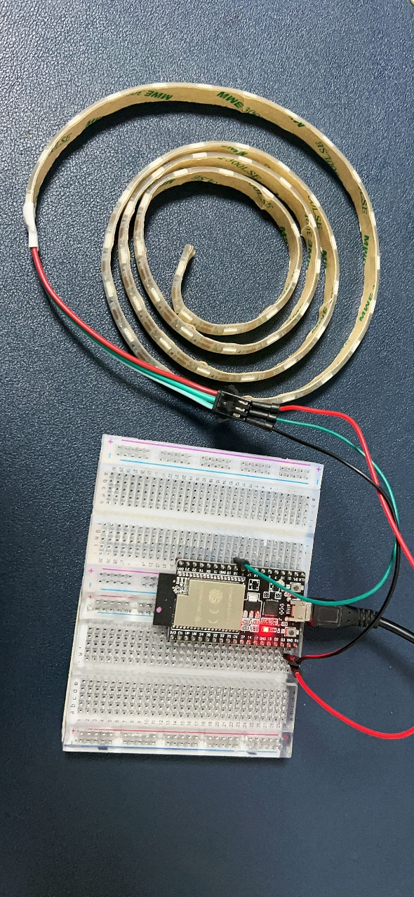

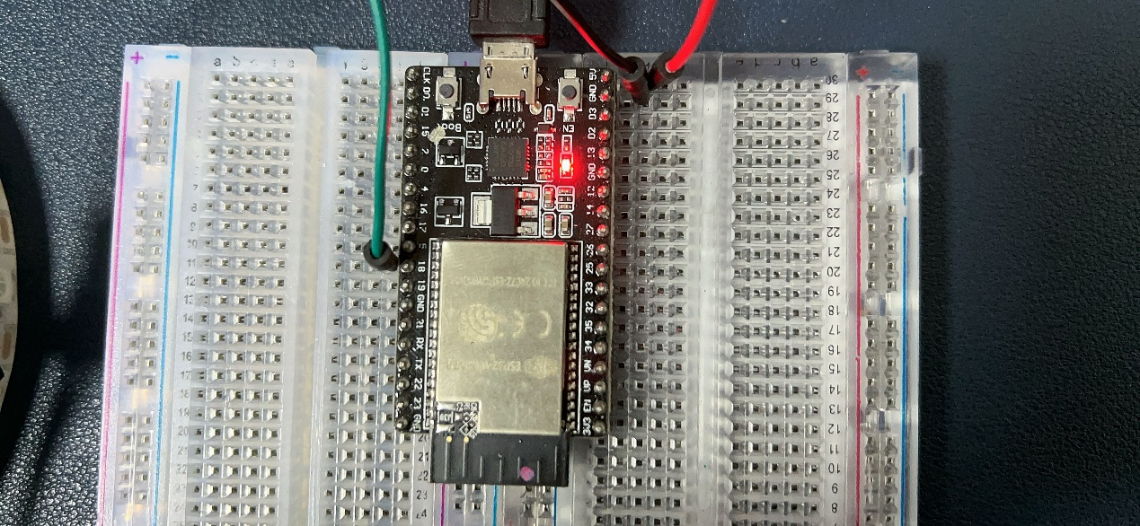

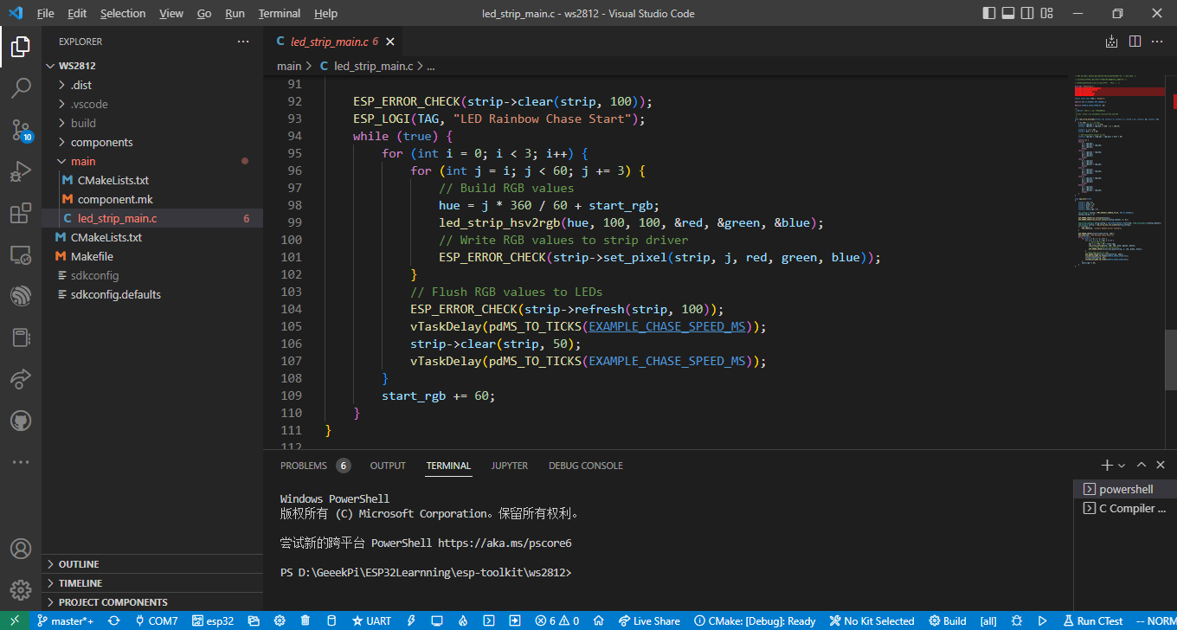

you can refer to <https://en.wikipedia.org/wiki/HSL_and_HSV> to understand the format and method of color conversion.

Building and flashing.

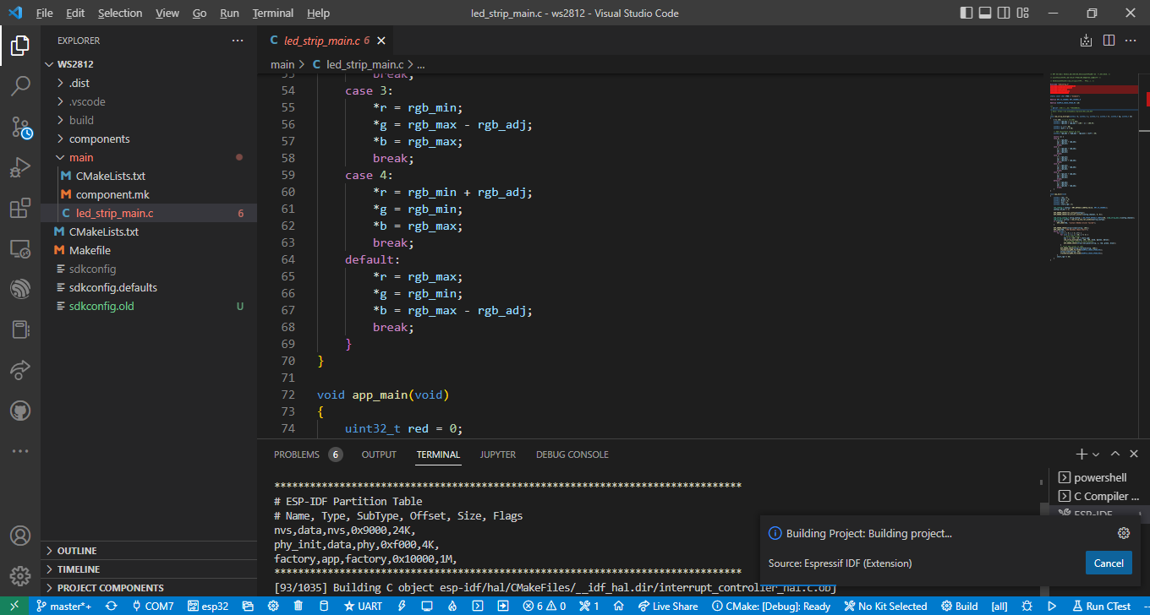

#### Final result:

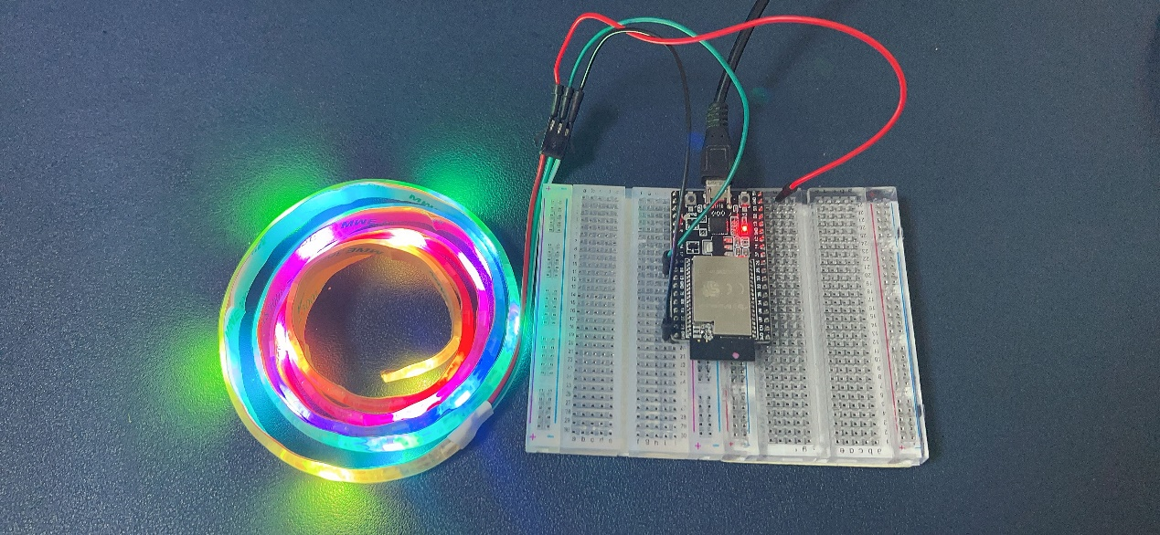

### OLED Display

#### Wiring:

|  |  |
| --- | --- |
| **ESP32 WROVER module** | **0.96inch OLED Display** |
| **3V3** | **VCC** |
| **GND** | **GND** |
| **IO5** | **SDA** |
| **IO4** | **SCL** |

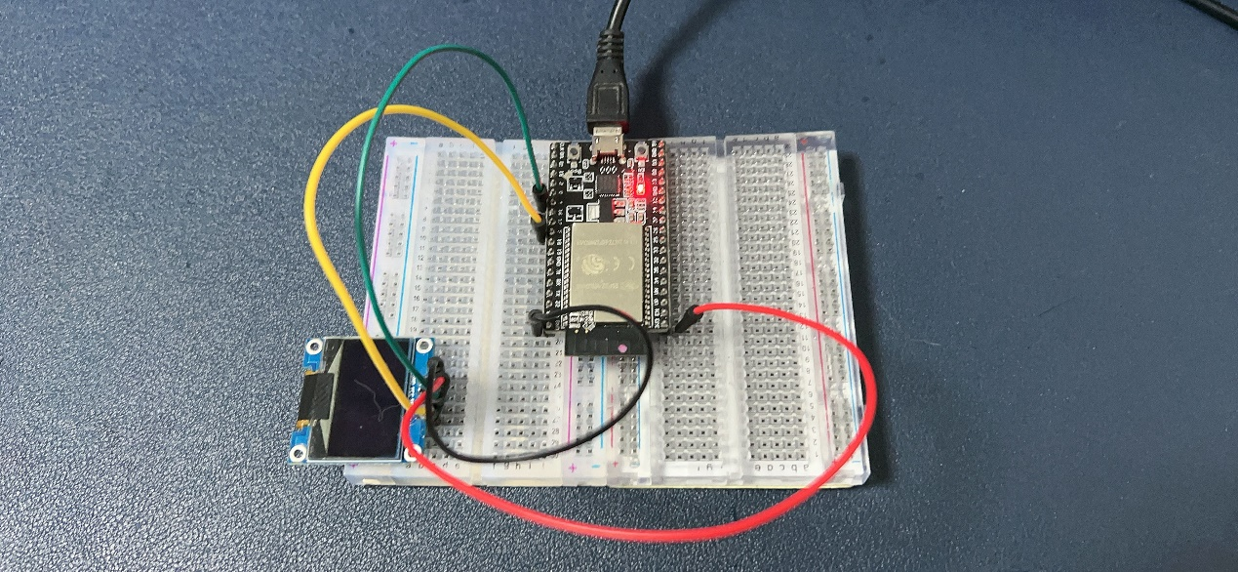

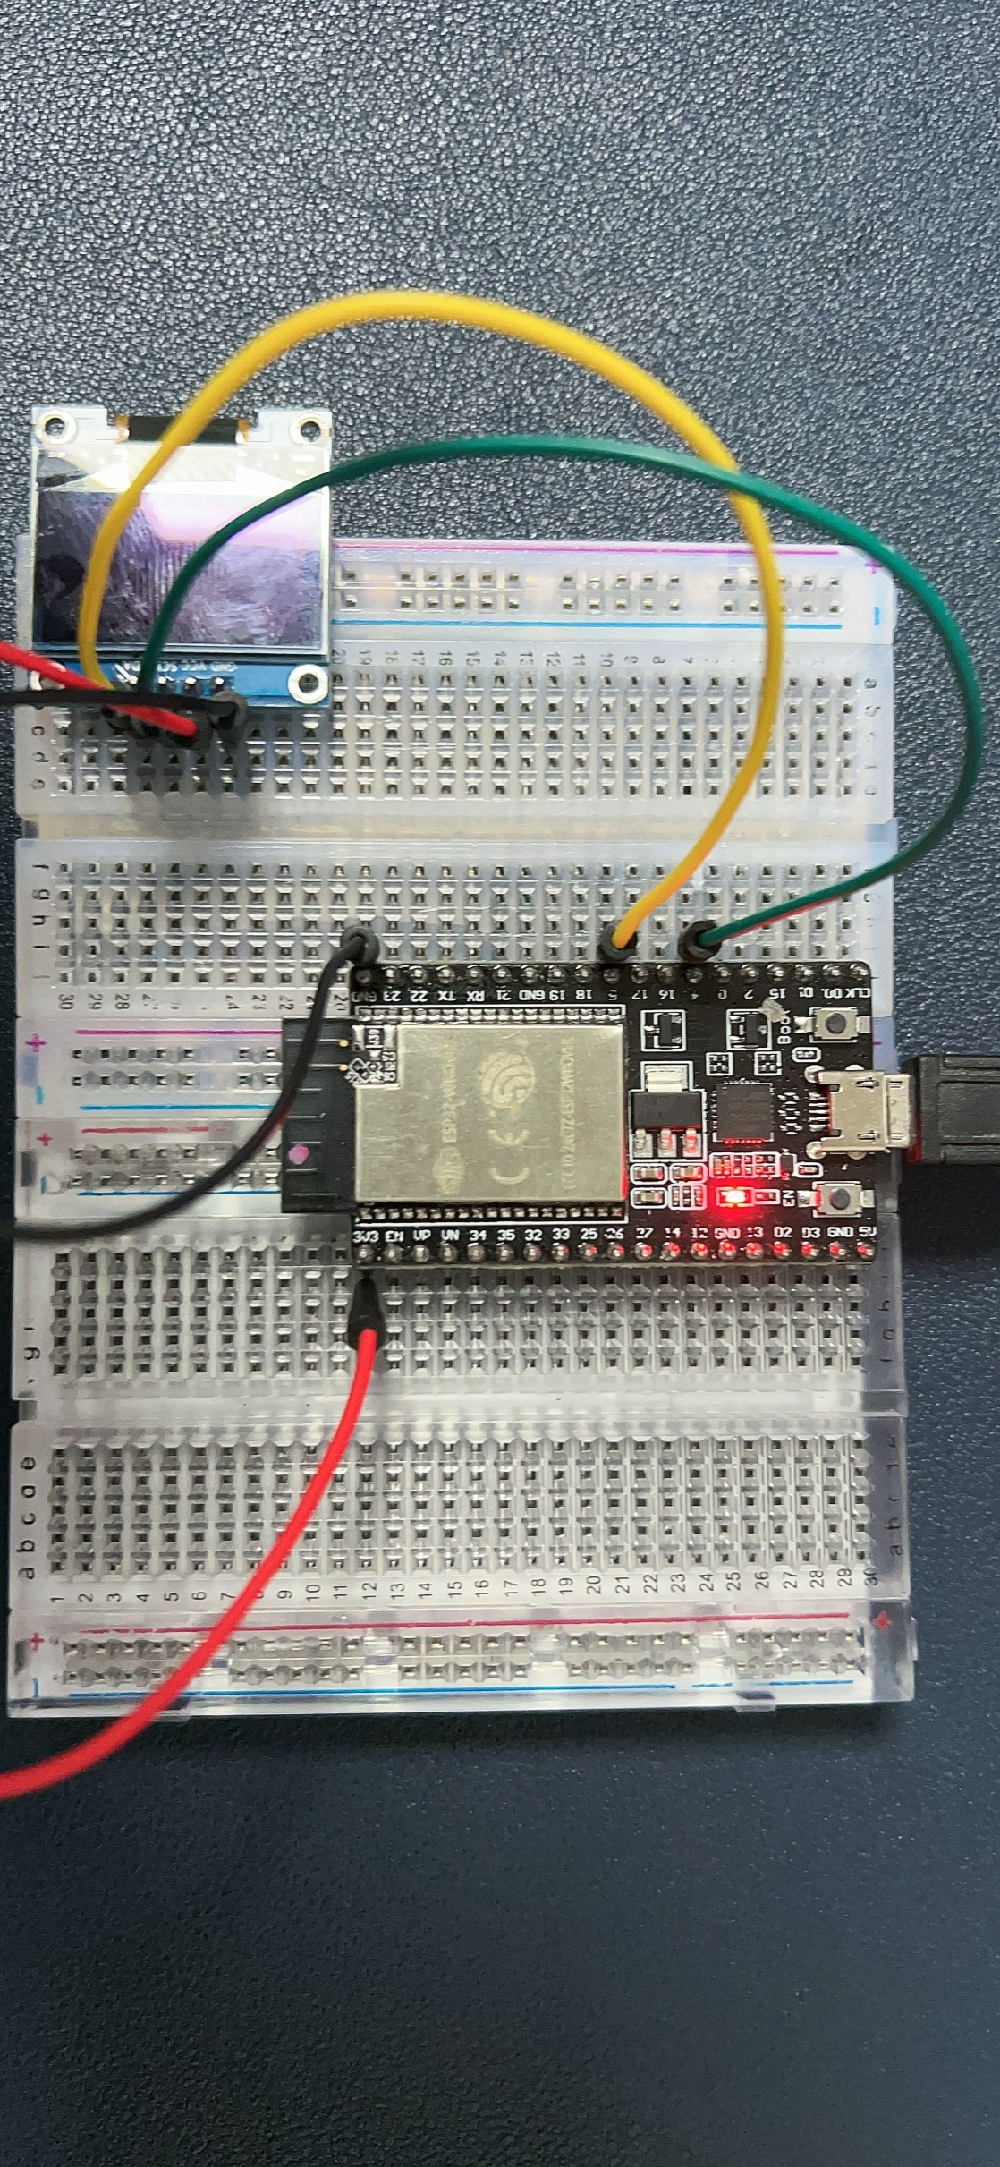

**NOTE：**

**You need to modify the undefined part in the ssd1306.c file, and check the error message of the first compilation in detail.**

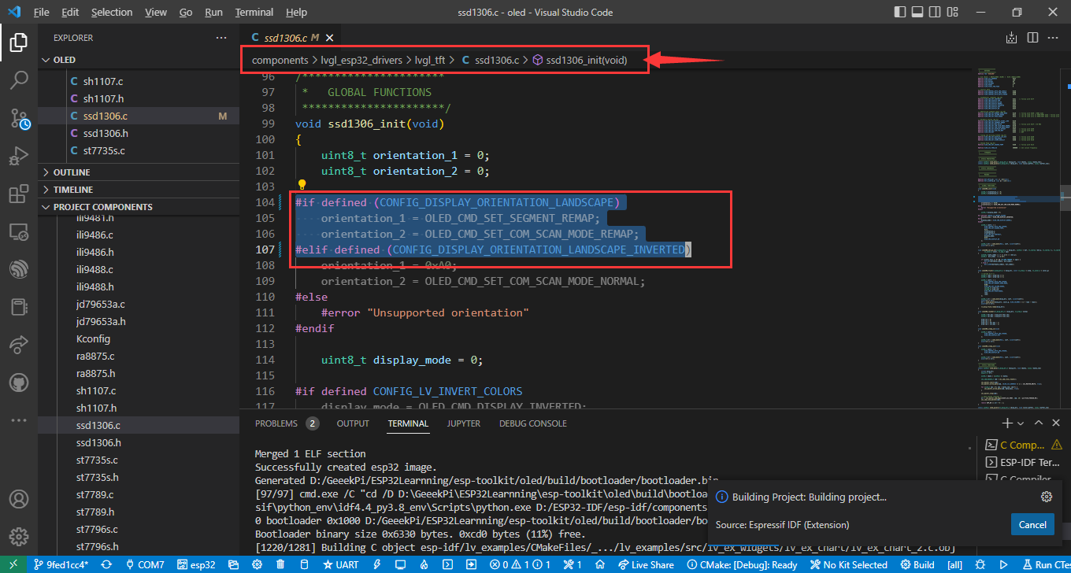

**You need to modify ssd1306.c file:**

**from:**

#if defined (CONFIG_LV_DISPLAY_ORIENTATION_LANDSCAPE)

    orientation_1 = OLED_CMD_SET_SEGMENT_REMAP;

    orientation_2 = OLED_CMD_SET_COM_SCAN_MODE_REMAP;

#elif defined (CONFIG_LV_DISPLAY_ORIENTATION_LANDSCAPE_INVERTED)

**to**

#if defined (CONFIG_DISPLAY_ORIENTATION_LANDSCAPE)

    orientation_1 = OLED_CMD_SET_SEGMENT_REMAP;

    orientation_2 = OLED_CMD_SET_COM_SCAN_MODE_REMAP;

#elif defined (CONFIG_DISPLAY_ORIENTATION_LANDSCAPE_INVERTED)

**remove “LV_” in that undefined parameter.**

**and rebuild the project, flash it, it will work fine.**

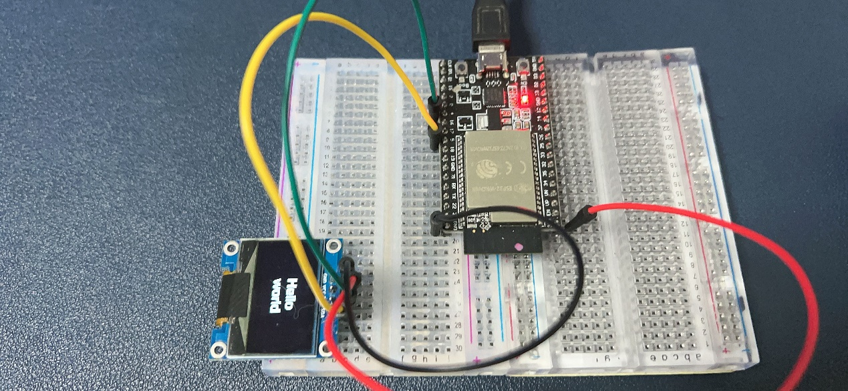

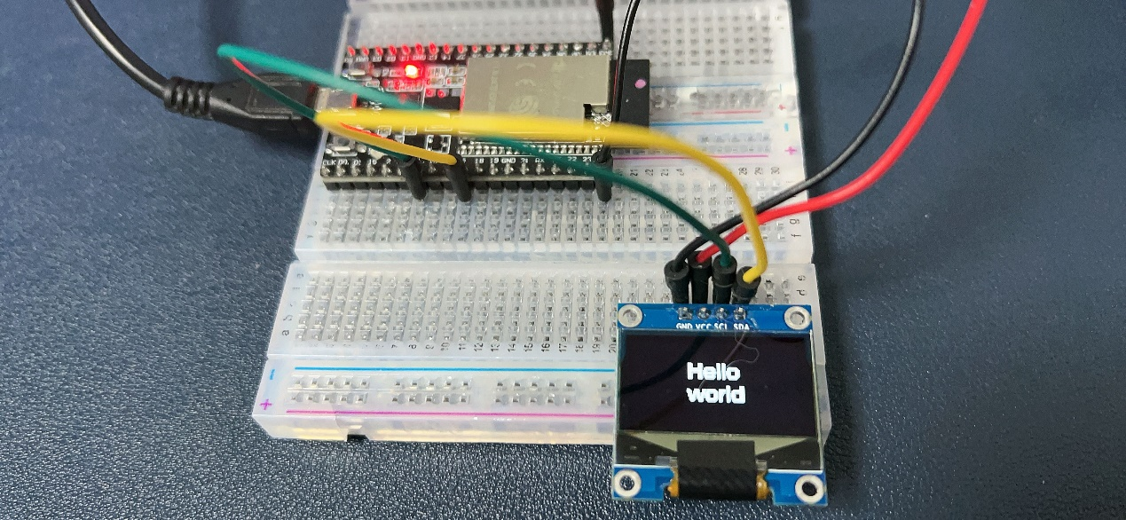

### 1.3‘IPS_LCD 240x240 pixels Display

#### Wiring:

|  |  |
| --- | --- |
| **ESP32 WROVER module** | **1.3‘IPS_LCD 240x240 pixels Display** |
| **3V3** | **VCC** |
| **GND** | **GND** |
| **IO13** | **SDA** |
| **IO14** | **SCL** |
| **IO4** | **RES** |
| **IO2** | **DC** |
| **IO15** | **CS** |
| **3V3** | **BLK** |

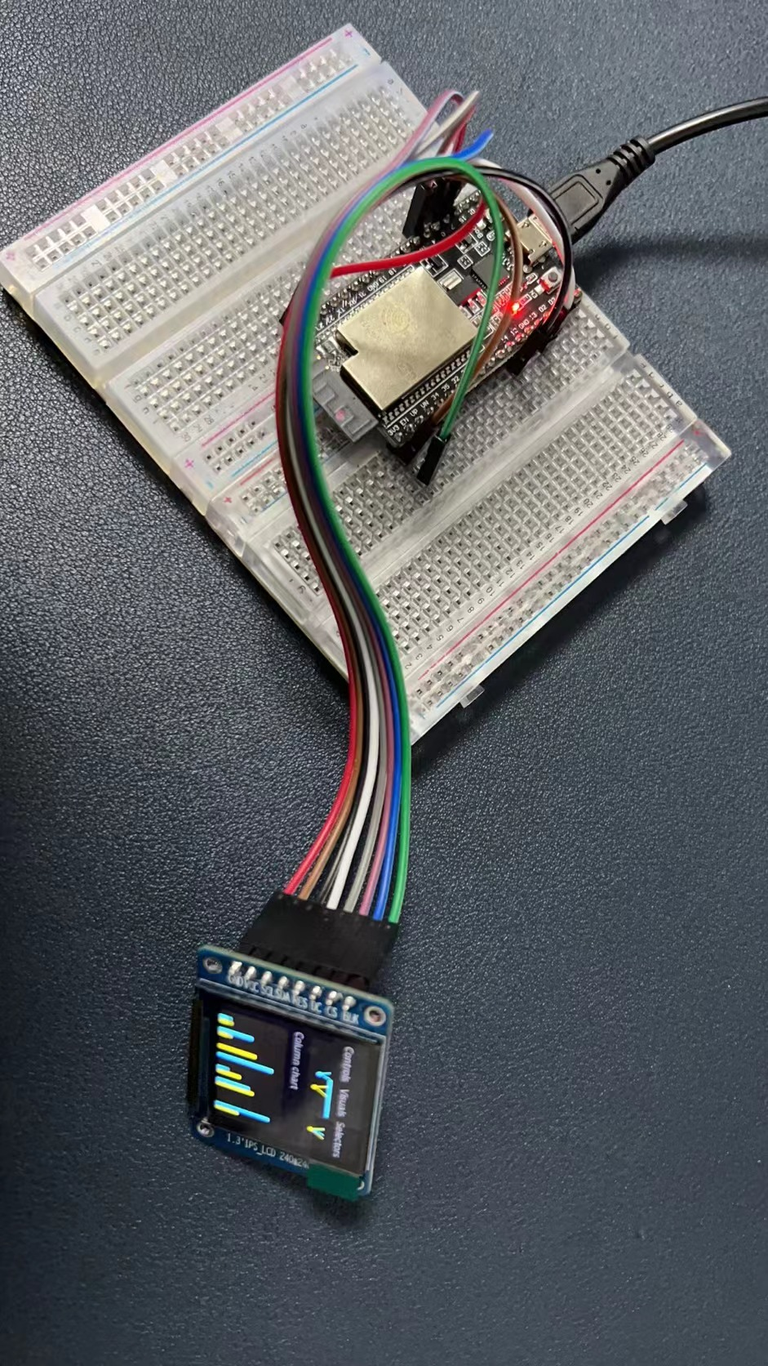

You need to download repository again by using this command:

git clone --recursive <https://github.com/geeekpi/esp-toolkit.git>

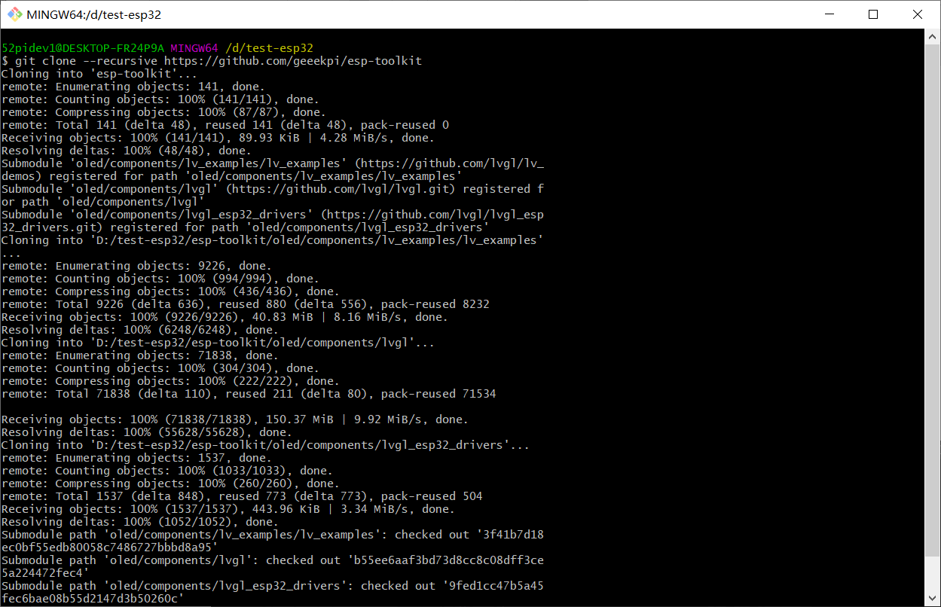

Open the project of OLED and modify sdkconfig as following:

Press Ctrl+Shift+P and input SDK:

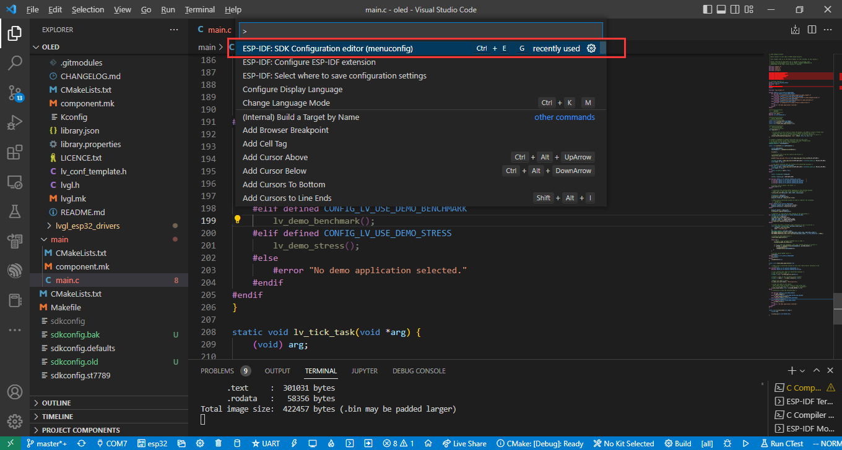

Navigate to LVGL TFT Display controller and modify as following figure.

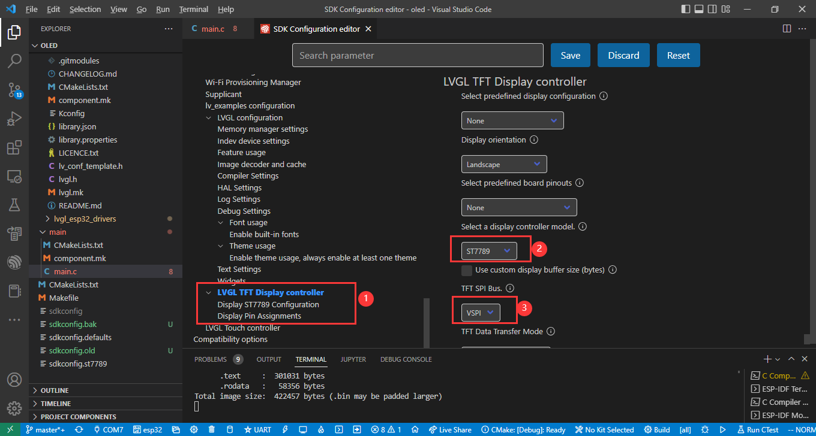

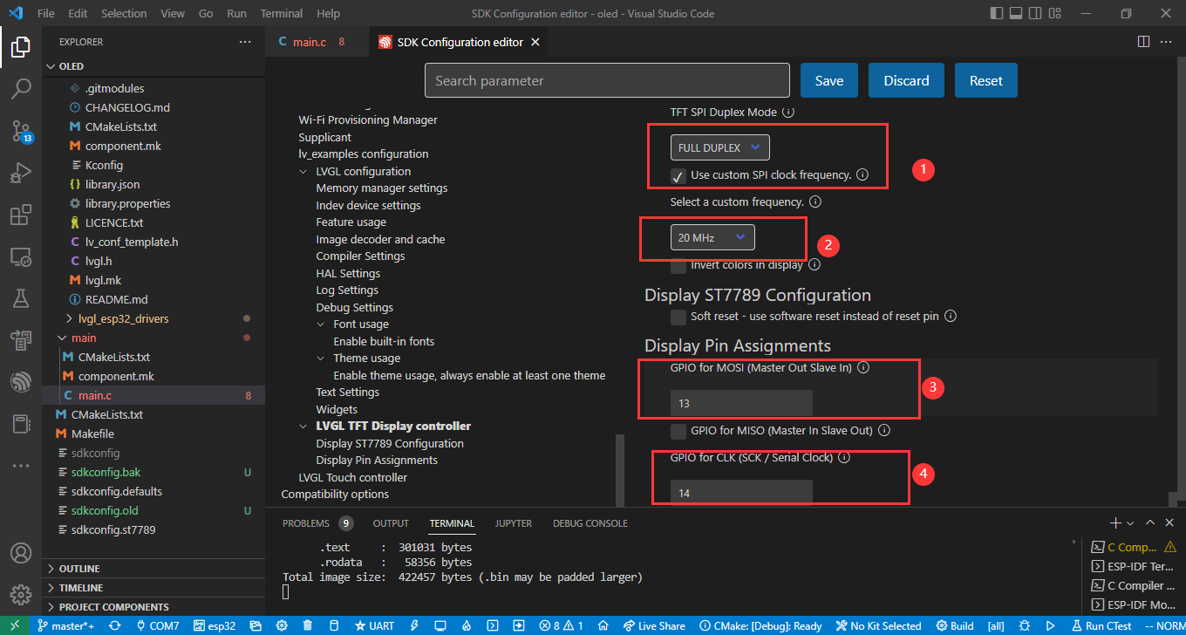

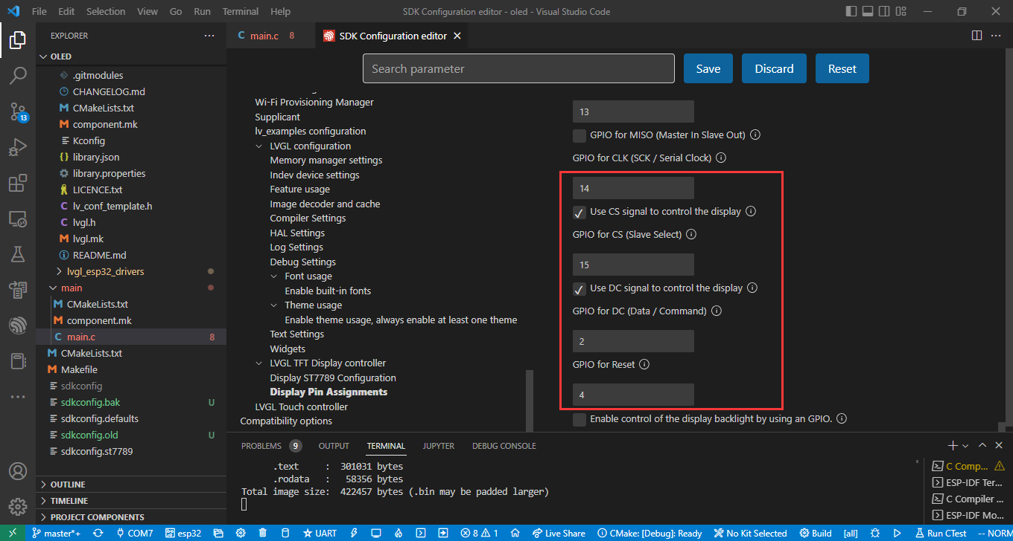

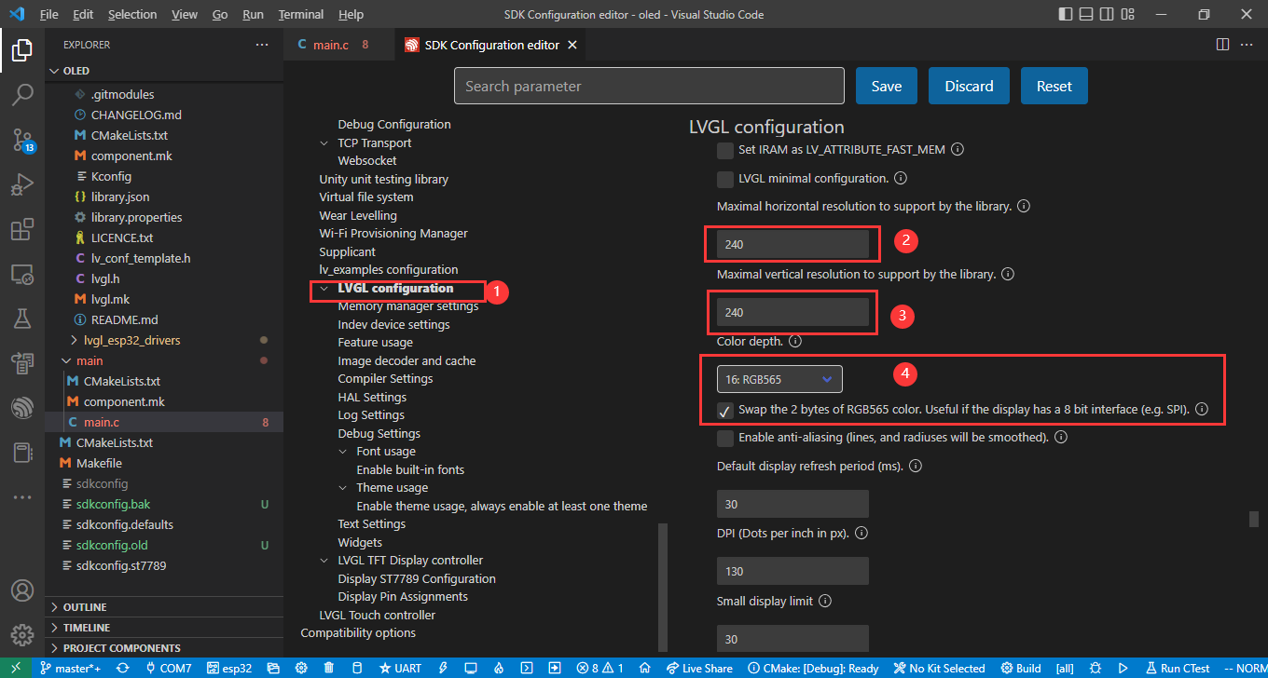

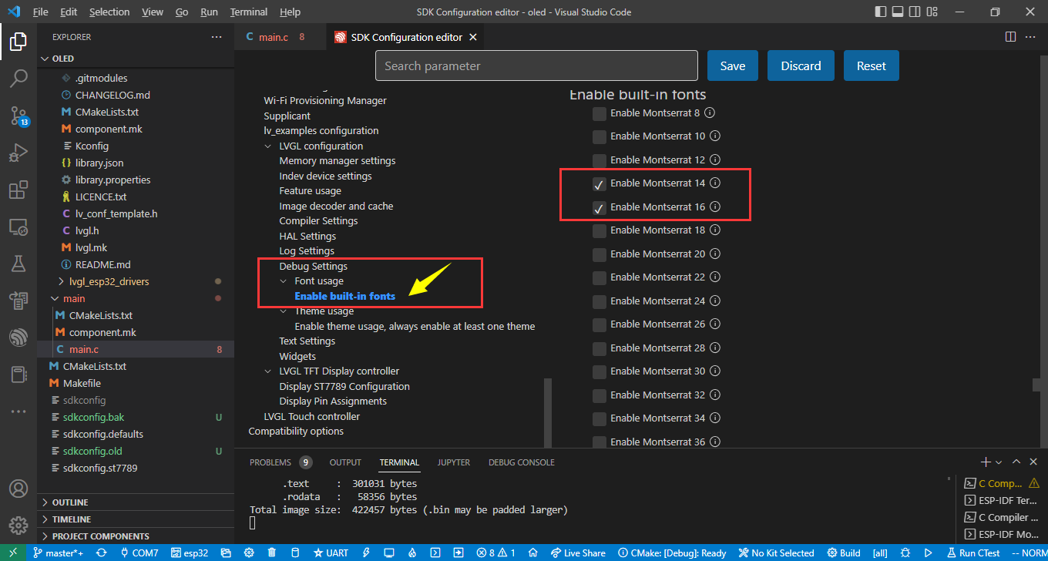

After configuring, click “save” to save the sdkconfig file, you can also just overwrite it from sdkconfig.st7789 file.

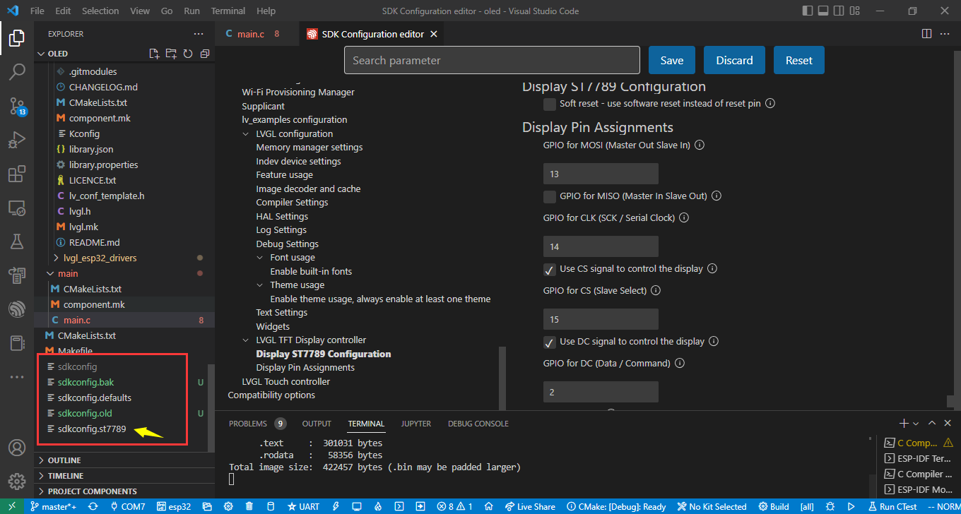

Now you can click “build” icon and flash it to your ESP32 WROVER board.

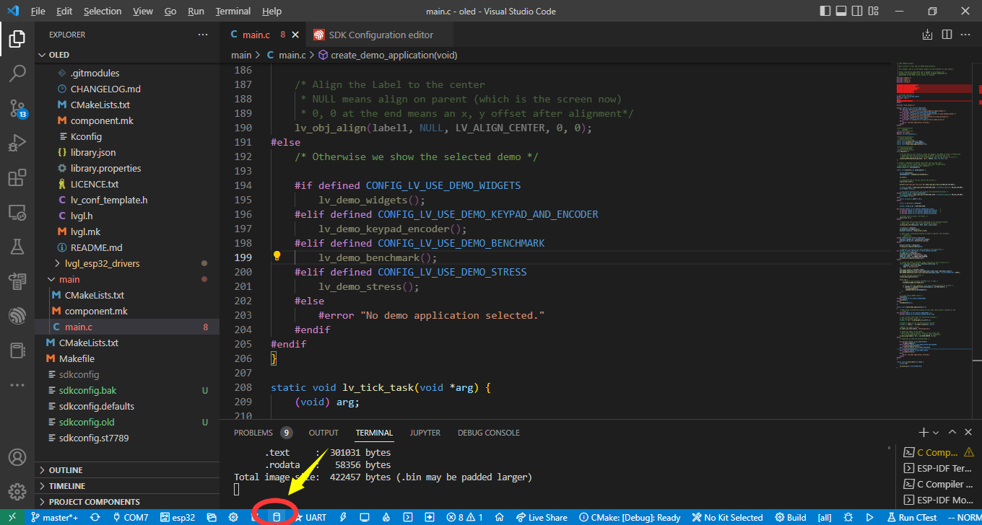

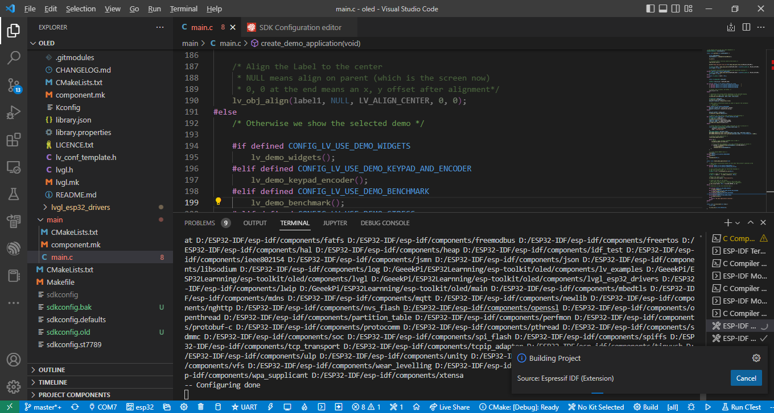

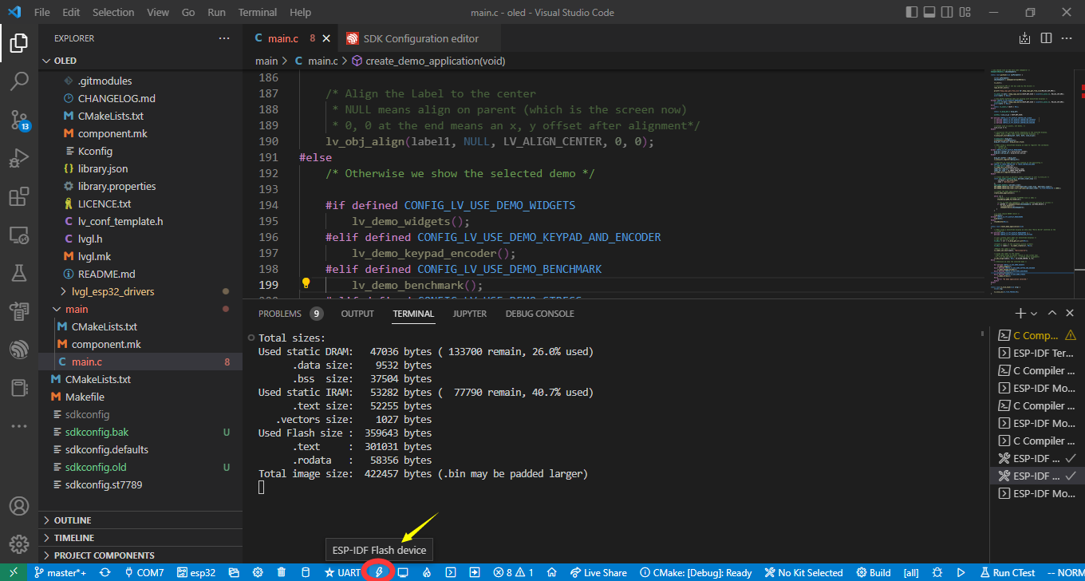

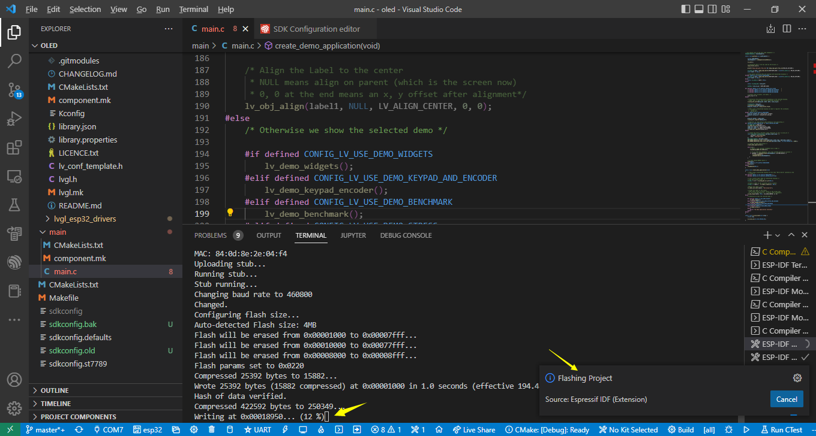

Then you will see the LVGL demo screen shows up.

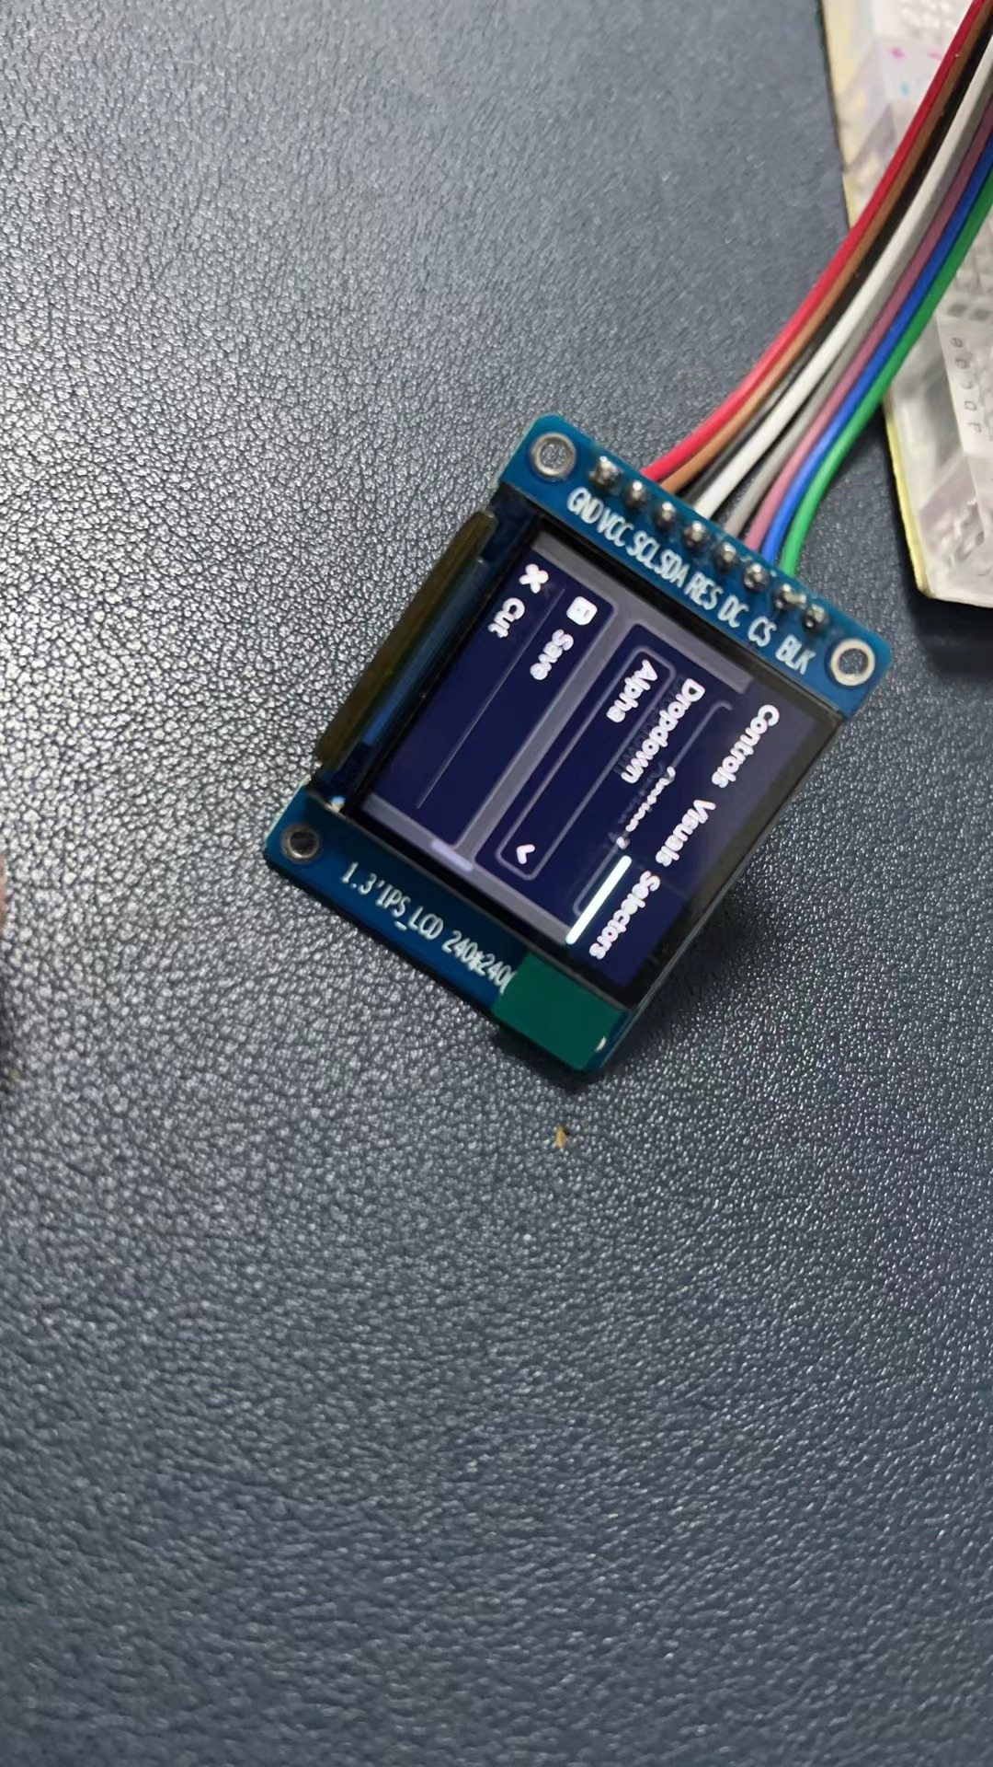

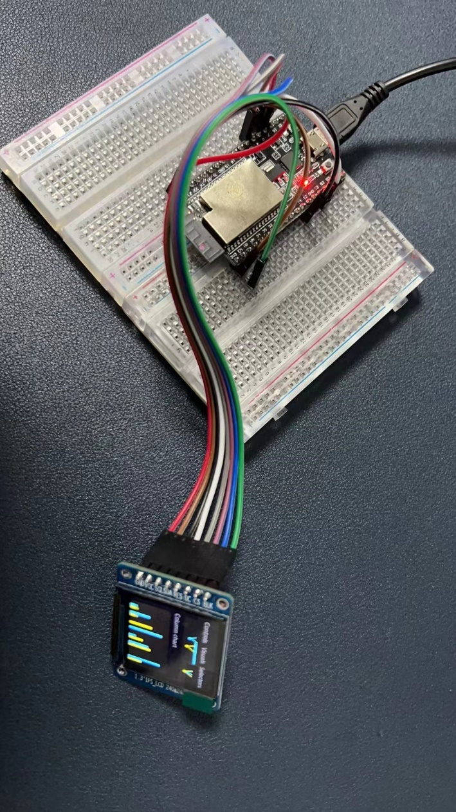

### Programming on Raspberry Pi Pico by using MicroPython

1. Download and install Thonny IDE or Mu IDE. (Refer to first section)

2. Download or Clone the Repository from GitHub: <https://github.com/geeekpi/superkit>

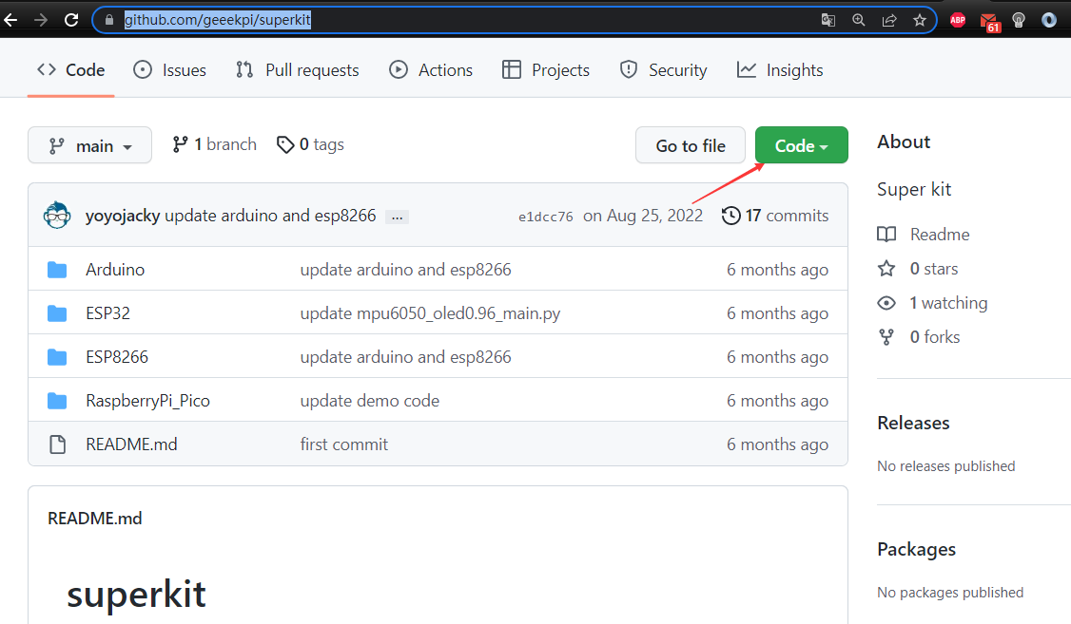

Navigate to “RaspberryPi_Pico” folder and open it, you will see demo codes and libs.

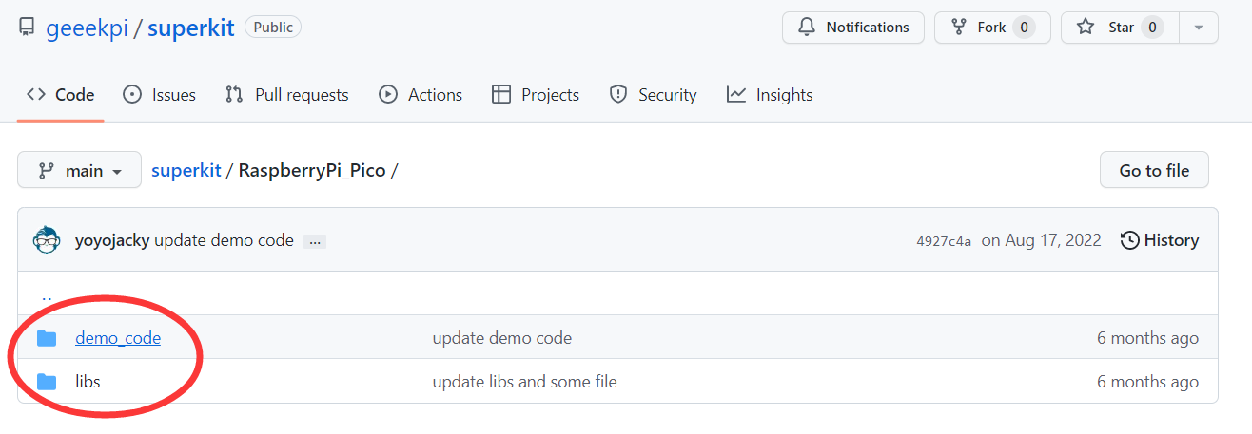Select one demo file and open it, copy the code to your thonny IDE or MU IDE’s editor window. for example:

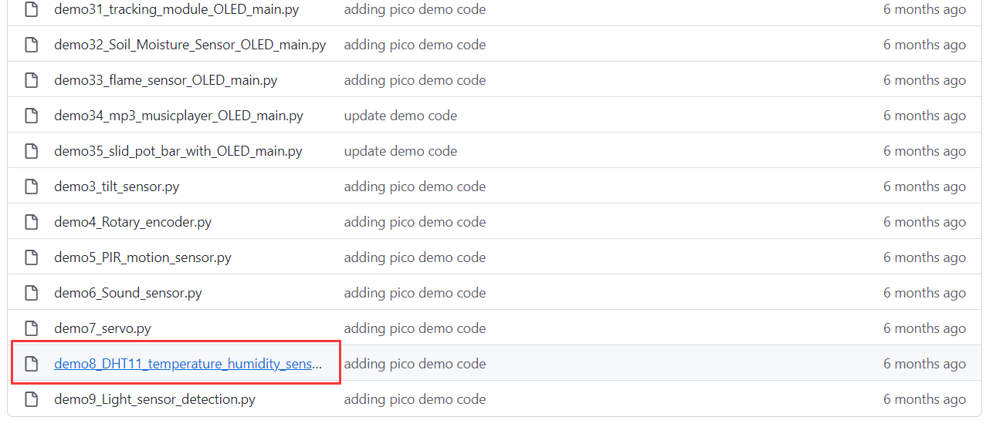

click the raw button and copy the code.

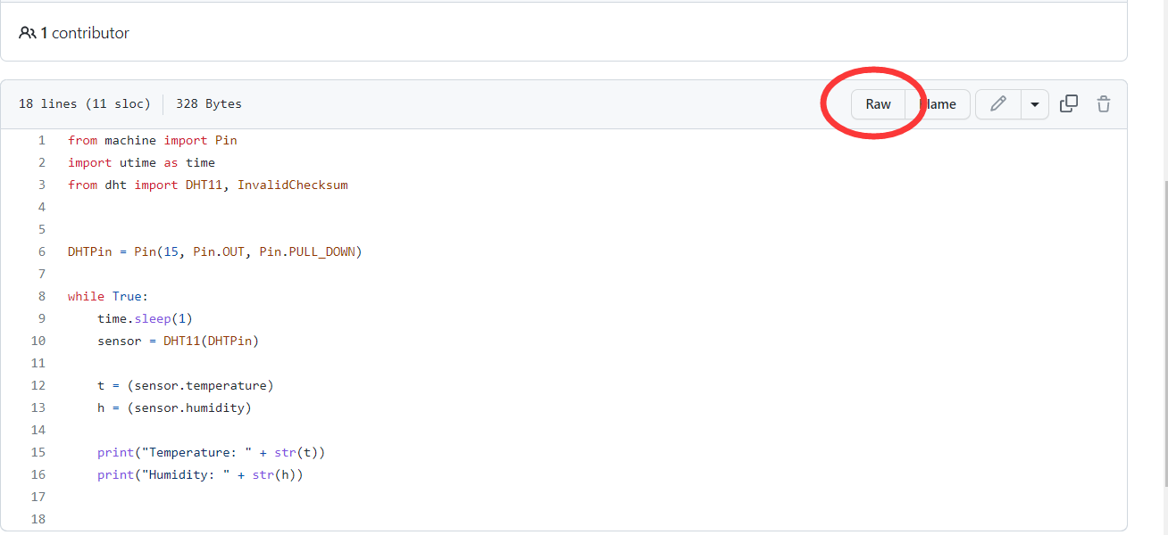

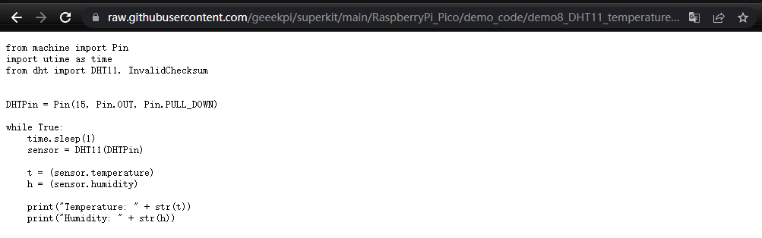

and then paste it to thonny IDE as following figure.

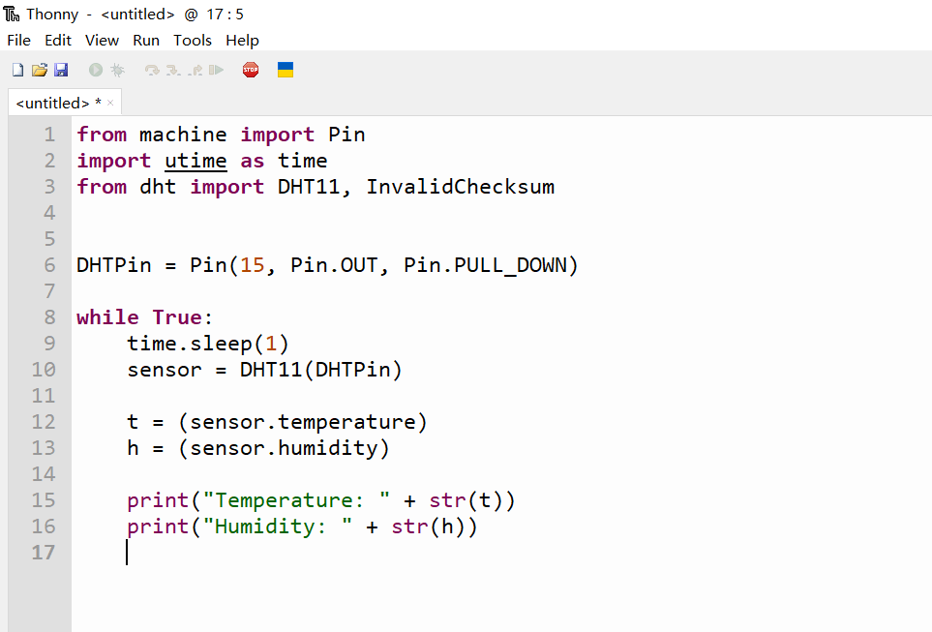

Connect Raspberry Pi Pico board to your laptop or PC by using MicroUSB cable, and then

Click Run on Thonny IDE menu, select “Configure interpreter…”

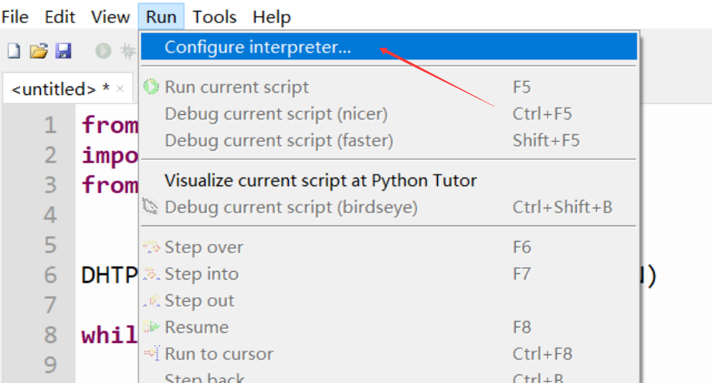

Setting interpreter as following figure:

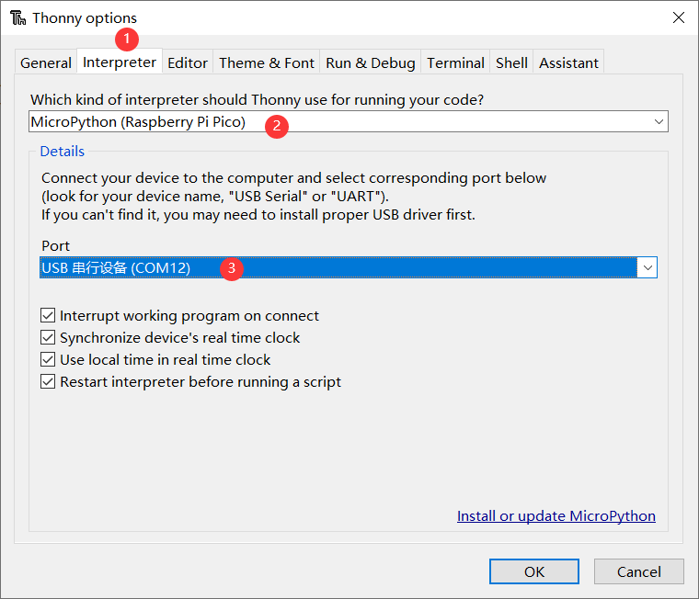

If you are using the Raspberry Pi Pico W at first time, if you want to program it with MicroPython, you can press the “BootSEL” button and reconnect the Raspberry Pi Pico W to your laptop or PC, and then select it as following figure:

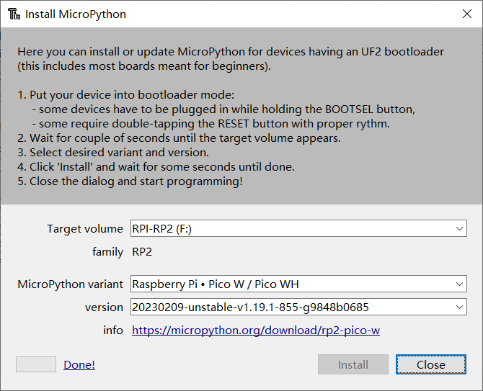

click install, it will download and install the firmware of MicroPython to your Pico automatically.

after that, Click File on Thonny IDE 🡪select “Save as” 🡪 select “Raspberry Pi Pico”

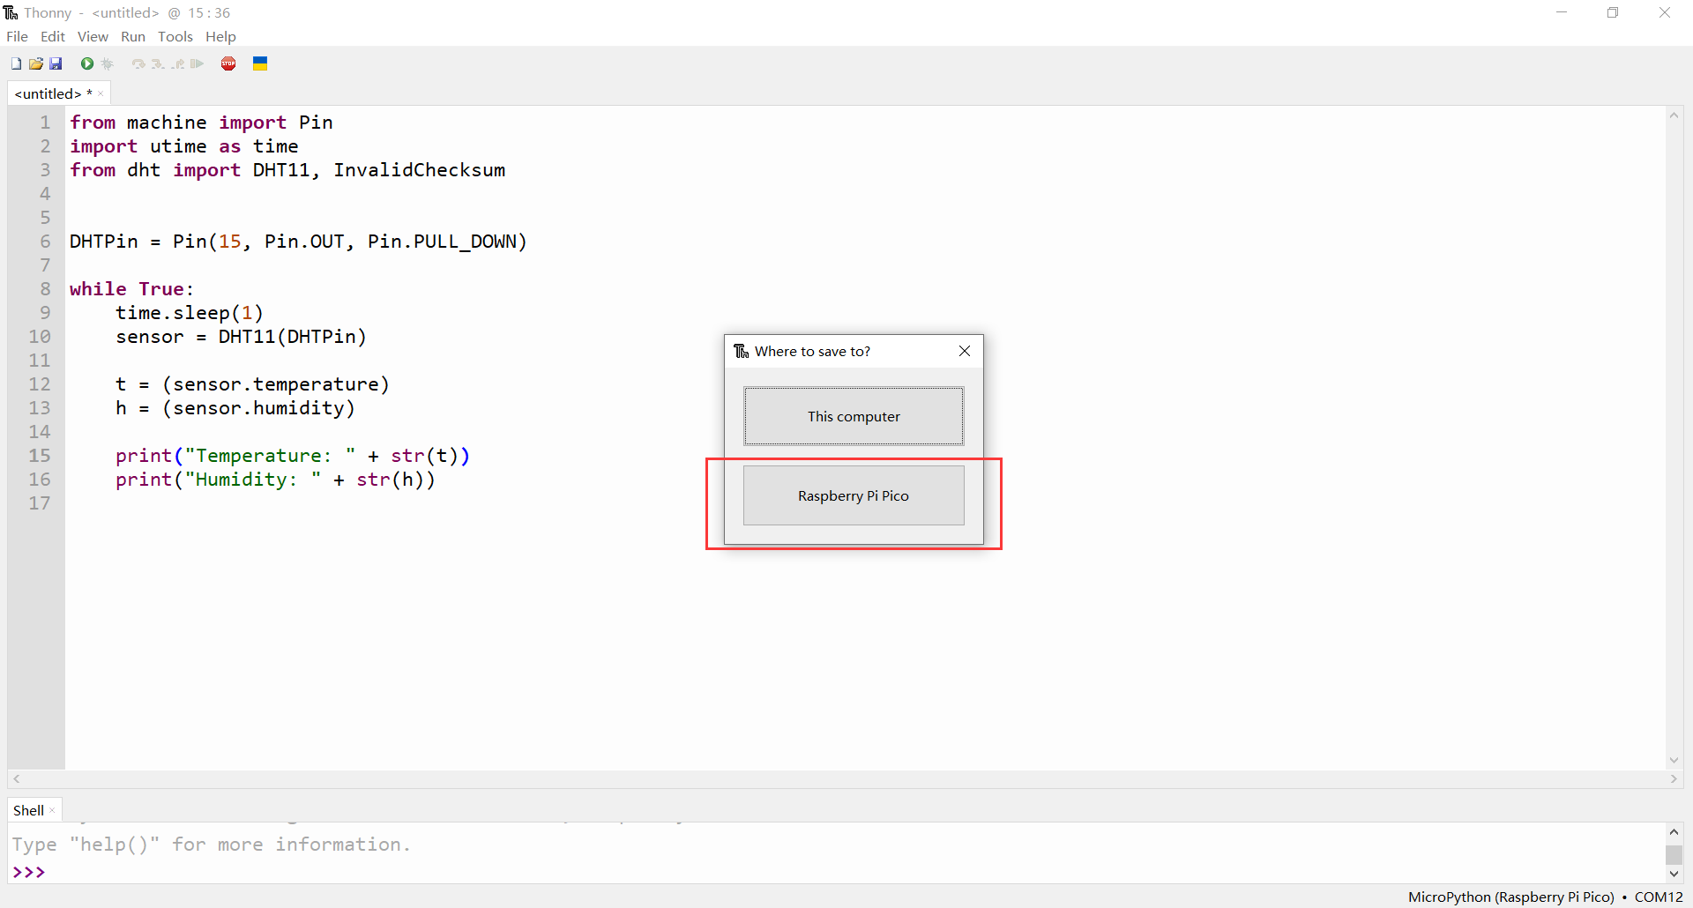

Do remember named it as “main.py”,

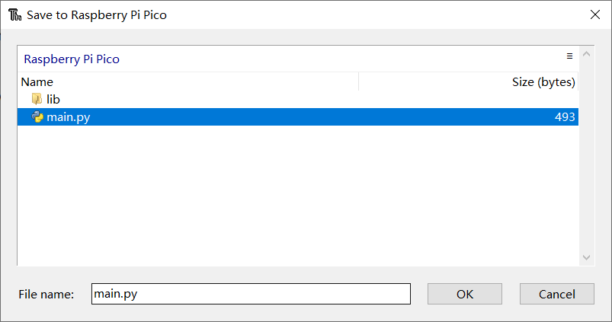

If your project needs some extra libraries, you can create a folder named “libs” by right click on blank area:

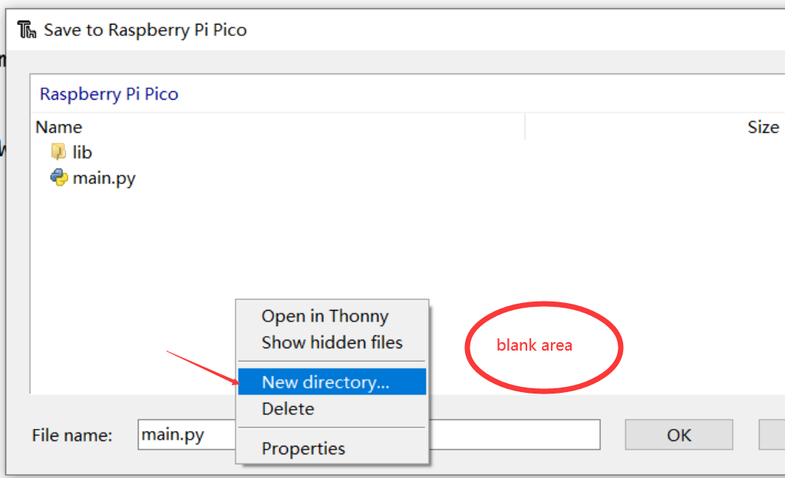

Use the same way to save the libraries file to libs folder and then click run icon on menu bar.

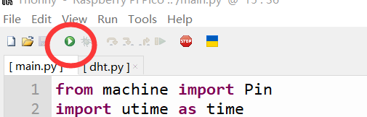

and then, check the results in Shell window:

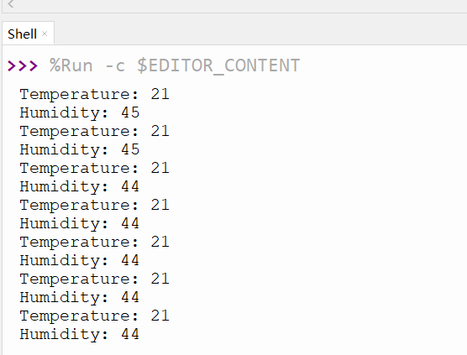

Please read the demo code carefully, especially the circuit wiring.

There are a lot of demo codes in the TF card included in the package. You can try to refer to the comments provided in the code and refer to the previous instructions, build the circuit according to the Pinout, compile and upload the test code, the code is open source code, feel free to use.

OK，Alright, grab your kit and start learning! When you encounter any problems, if google can't help you, please contact us directly, we are willing to answer your questions for you！

Please contact us by sending email to: [admin@52pi.com](mailto:admin@52pi.com) or join our Facebook Group, <https://www.facebook.com/groups/geeekpi/>.